**Operational Inconveniences of Heavy-Duty Electric Vehicles in Cleveland, Ohio: Through Fleet Operators Prospective**

**Abstract**

This thesis examines the operational inconveniences encountered by fleet operators in Cleveland, Ohio, during the adoption of Heavy-Duty Electric Vehicles (HD EVs), using a structured, data-driven approach. As climate concerns grow, the transportation sector—especially diesel-powered heavy-duty vehicles—faces scrutiny for its high emissions. While passenger EV adoption is accelerating, the shift to HD EVs remains limited due to unique technological, infrastructural, and economic barriers.

Fleet operators considering the adoption of HD EVs face complex trade-offs involving vehicle range, charging time, infrastructure reliability, high upfront investment, and battery health. These operational barriers must be carefully understood and prioritized to ensure a practical and feasible transition from conventional diesel fleets to sustainable electric alternatives.

To systematically evaluate these challenges, this research adopts a three-stage methodology. First, an extensive quantitative data analysis was conducted, utilizing real-world datasets related to vehicle usage, cost comparisons, charging patterns, infrastructure availability, and predictive maintenance. This stage enabled the identification of the most pressing operational inconveniences using empirical trends rather than anecdotal evidence.

Second, a weighted scoring method was applied to assign preliminary importance to each identified inconvenience based on both analytical findings and expert-informed impact scales. This step translated complex operational barriers into quantifiable and comparable criteria.

Finally, the study employs the Best-Worst Method (BWM)—a robust multi-criteria decision-making framework that enhances prioritization by comparing the most and least significant challenges through structured pairwise comparisons. This approach ensures logical consistency, minimizes bias, and delivers optimized weightings for each operational factor.

The findings highlight that charging infrastructure availability, high upfront costs, and charging time inefficiencies are the most critical barriers for HD EV adoption in Cleveland. Issues such as limited vehicle range, battery degradation, and policy uncertainties also emerged as significant, though comparatively less influential. The study provides a prioritized ranking of these challenges, offering a clear roadmap for action.

Based on these insights, the research presents data-driven recommendations for manufacturers, policymakers, and fleet operators. These include investing in rapid-charging infrastructure, supporting cost-reduction strategies for electric trucks, and enhancing incentive programs targeted at commercial fleet transitions. For manufacturers, the findings point toward the need for innovation in battery longevity and vehicle range optimization.

By focusing specifically on Cleveland—a mid-sized city with distinct geographic and economic features—this thesis not only sheds light on local challenges but also contributes a replicable decision-making framework applicable to other urban regions navigating similar transitions. The ultimate aim is to support the strategic acceleration of HD EV adoption and contribute meaningfully to the broader goals of sustainable and low-emission transportation.

**Chapter 1**

**Introduction**

* 1. **Background**

Transportation is a cornerstone of modern society, playing a vital role in facilitating economic growth, social interactions, and overall quality of life. As one of the primary drivers of economic activity, it enables the movement of goods and people across regions, supporting both domestic and international commerce. However, despite its essential role in our daily lives, the transportation sector also presents significant environmental and public health challenges. In particular, it is a leading contributor to the emission of greenhouse gases (GHGs), with road transportation being the primary culprit.

In the United States, transportation accounts for approximately 27% of total greenhouse gas emissions, with a substantial portion of these emissions stemming from heavy-duty vehicles (HDVs) such as trucks and buses (EPA, 2015). Despite making up less than 5% of the total vehicle fleet, HDVs are responsible for nearly 27% of vehicle fuel consumption and carbon dioxide (CO₂) emissions (EIA, 2019). Globally, the heavy-duty vehicle segment is even more concerning. These vehicles represent only about 11% of the total fleet, yet they are responsible for nearly 50% of total CO₂ emissions and 71% of particulate matter (PM) emissions from motor vehicles (Kodjak, 2015). In developing countries, the environmental impact of HDVs is even more pronounced, as these vehicles contribute disproportionately to urban air pollution and associated health issues (Apte et al., 2017; Guttikunda et al., 2014).

These challenges have prompted calls for the electrification of the transportation sector. By replacing fossil fuel-powered vehicles with electric alternatives, the industry could drastically reduce emissions, improve air quality, and decrease reliance on finite resources such as oil. The growing interest in electric vehicles (EVs), especially in the heavy-duty segment, offers a promising solution to these problems. However, despite the clear environmental benefits, transitioning to electric heavy-duty vehicles (HD EVs) is not without its challenges. The shift requires overcoming barriers such as high initial costs, limited charging infrastructure, and concerns about vehicle range and performance.

To better understand the magnitude of the issue, **Figure 1.1** below illustrates the breakdown of greenhouse gas emissions by sector in the U.S., highlighting the dominant role of transportation in overall emissions. As seen in the chart, transportation is the leading source of emissions, which underscores the urgency of addressing the environmental impacts of this sector.

As illustrated in **Figure 1.2**, emissions from HDVs are particularly concerning. Despite their small share of the vehicle fleet, HDVs are responsible for a disproportionate amount of carbon emissions and air pollutants, making their electrification a crucial goal in reducing overall transportation-related emissions.

**Figure 1.1: GHG Emissions by Sector in the U.S. (2022)**

Despite the obvious environmental benefits of electrifying HDVs, the transition is complicated by several factors. High upfront costs, lack of widespread charging infrastructure, and concerns about vehicle range are some of the primary barriers preventing the rapid adoption of electric heavy-duty vehicles. However, the growing global push towards electrification, combined with technological advances in battery storage and renewable energy sources, presents a clear opportunity to overcome these challenges.

The increasing availability of clean energy sources, such as wind and solar, has already made it easier to transition to electric passenger vehicles, and similar progress is necessary for the heavy-duty sector. To this end, it is crucial to address not only the technical and economic barriers to HD EV adoption but also the policy and infrastructure gaps that currently limit the widespread deployment of electric trucks and buses.

**Figure 1.2: GHG Emissions from HDVs in the U.S.**

Although the benefits of EVs are well-documented, adoption of **HD EVs** continues to face several significant challenges. Pamidimukkala et al.[37] conducted a comprehensive global review identifying and classifying the core barriers to EV adoption. Key barriers relevant to heavy-duty applications include:

* High Initial Costs: HD EVs often come at a 50–70% premium compared to diesel alternatives, posing a major hurdle for budget-constrained fleet operators.
* Limited Charging Infrastructure: A lack of accessible, high-capacity charging—particularly for long-haul and regional routes—impedes practical deployment.
* Battery Performance and Range Anxiety: Degradation over time, high energy demands, and long recharge durations reduce operational reliability and increase uncertainty.
* Uncertainty Around Maintenance and Lifecycle Economics: With limited real-world fleet data, many operators are hesitant to invest in technology with unknown long-term costs.
* Policy Gaps and Consumer Awareness: Inconsistent regulatory incentives and a lack of fleet-focused EV education further delay large-scale adoption.

These challenges emphasize the urgent need for localized, fleet-level analysis—such as the one conducted in this thesis—to identify, weigh, and prioritize the operational inconveniences most critical to HD EV adoption in Cleveland.

* 1. **The Need for Electrification**

The global push for electrification of transportation is increasingly seen as one of the most viable solutions to combat climate change and reduce the environmental impacts of the transportation sector. With transportation being one of the largest contributors to greenhouse gas emissions globally, the transition to electric vehicles (EVs) offers an important opportunity to significantly cut down carbon footprints and promote sustainability. This shift is seen not only as a solution to mitigate climate change but also as a means to improve air quality and public health by reducing harmful emissions that come from traditional fossil fuel-powered vehicles.

Over the past few decades, electric vehicles have evolved dramatically in terms of performance, efficiency, and accessibility. Initially, EVs were seen as niche alternatives to conventional gasoline-powered vehicles, primarily limited by issues such as short driving ranges, long charging times, and relatively high purchase prices. However, modern electric vehicles have made significant strides in overcoming these barriers. Advancements in battery technology, vehicle efficiency, and after-treatment systems have all contributed to substantial improvements in both the driving range and performance of electric cars. These innovations have allowed for more affordable, efficient, and accessible electric vehicles. For example, battery electric vehicles (BEVs) and plug-in hybrid electric vehicles (PHEVs) are now able to travel longer distances on a single charge compared to earlier models, making them more suitable for everyday use and long-distance travel.

According to Moultak et al. (2017), the adoption of electric vehicles has the potential to reduce emissions by as much as 80% over the vehicle's lifecycle when compared to conventional gasoline or diesel vehicles. While conventional internal combustion engine vehicles have reduced emissions by up to 40% over the last few decades, largely through improved fuel efficiency and after-treatment technologies, zero-emission vehicles (ZEVs) promise an even more drastic reduction in emissions. ZEVs, including battery-electric and hydrogen fuel-cell vehicles, produce no tailpipe emissions, making them a key technology in the fight against air pollution and climate change. The shift from conventional vehicles to EVs not only helps to reduce direct emissions from vehicles but also contributes to cleaner air in urban areas, where vehicle emissions are often the primary source of air pollution.

Additionally, the electrification of transportation is critical to reducing dependence on fossil fuels, which are finite and contribute to environmental degradation. By shifting to electric vehicles, the transportation sector can tap into a wider range of cleaner energy sources, such as renewable electricity generated from solar, wind, and hydropower. This shift is particularly significant in the United States, where the electricity sector is undergoing a gradual transition toward greener energy sources. From 2008 to 2018, wind and solar energy accounted for 44% of the added electricity capacity in the U.S., a trend that is expected to continue as more states and territories make commitments to sustainable energy ([Phadke et al., 2021](https://www.renewableenergyworld.com" \t "_new)).

As of 2021, more than ten states and territories, including Washington D.C. and Puerto Rico, have pledged to move toward 100% clean or renewable energy to meet their power needs ([Phadke et al., 2021](https://www.renewableenergyworld.com" \t "_new)). This move toward renewable energy complements the adoption of electric vehicles, as the energy used to charge these vehicles increasingly comes from sustainable sources rather than fossil fuels. This cleaner energy infrastructure not only helps reduce the carbon footprint of electric vehicles but also enhances their environmental benefits, making the transition to electric transportation even more viable.

Furthermore, renewable energy adoption creates an opportunity to create a closed-loop system in which the electricity used to charge EVs comes from the same clean, sustainable sources that are powering the grid. This would lead to significant reductions in global carbon emissions as well as improvements in energy security, by decreasing reliance on imported fossil fuels. With the increasing affordability of renewable energy technologies, the gap between the energy demands of electric vehicles and the capabilities of renewable energy sources is closing, further driving the case for electrification.

The electrification of transportation is also supported by advancements in energy storage technologies. Battery storage systems, such as large-scale lithium-ion batteries, are critical to ensuring that energy generated from intermittent renewable sources like wind and solar can be stored and used when demand is high. This energy storage capability not only facilitates the charging of electric vehicles but also contributes to grid reliability, making the transition to a cleaner and more resilient energy system both feasible and sustainable.

As more regions adopt electric vehicles and renewable energy sources, the cumulative impact of these efforts will play a critical role in addressing the climate crisis. The decarbonization of the transportation sector, which is one of the largest contributors to greenhouse gas emissions, will not only help limit global warming but will also lead to cleaner air, reduced health care costs, and a more sustainable future for generations to come.

In conclusion, the need for electrification in transportation has never been clearer. With technological advancements, renewable energy adoption, and the potential for drastic emissions reductions, the transition to electric vehicles offers a unique and necessary opportunity to combat the pressing environmental challenges of our time. While challenges remain, including the cost and infrastructure needs for electric vehicles, the pathway toward cleaner, more sustainable transportation is both achievable and critical for a healthier planet.

* 1. **Current Challenges in Heavy-Duty Vehicle Electrification**

The adoption of electric vehicles (EVs) has seen widespread success in the passenger vehicle sector, with electric cars becoming increasingly common on the roads. However, the electrification of heavy-duty commercial vehicles (HD EVs) is still in its early stages and faces unique challenges that make the transition significantly more difficult than for passenger cars. Heavy-duty vehicles, such as long-haul trucks, buses, and delivery vehicles, are designed to carry larger loads, travel longer distances, and operate for extended hours—needs that electric vehicles are still struggling to meet efficiently.

One of the primary barriers to electrifying these vehicles is the power requirements. Unlike passenger cars, HDVs need much larger and more powerful batteries to meet their operational needs. For example, long-haul trucks require batteries that can sustain higher energy demands over long distances, and the heavy weight of the vehicle itself adds complexity. These trucks are built to carry heavy cargo for extended periods, which requires a level of energy storage that current battery technology can struggle to provide, particularly at competitive costs.

The cost of electric truck technology is another significant hurdle. While electric cars have become more affordable, heavy-duty electric trucks remain expensive, primarily due to the high cost of batteries. Batteries are a crucial component of EVs, and although their prices have been decreasing over the years, the cost of a large battery for a heavy-duty vehicle is still a major obstacle to the widespread adoption of HD EVs. Fleet operators are often hesitant to invest in these vehicles because of their high upfront costs, despite the long-term savings on fuel and maintenance.

Another key concern for fleet operators is the operational range of electric trucks. Diesel trucks have the ability to travel long distances without the need for frequent refueling, which is vital for long-haul operations. In contrast, electric trucks still face significant range limitations. While the range of electric vehicles has improved in recent years, many electric trucks still fall short of the range offered by their diesel counterparts. This becomes even more problematic when considering the charging times associated with electric trucks. Unlike a diesel vehicle, which can be refueled in just a few minutes, electric trucks require much longer charging times, and these charging stations are not always readily available, especially in rural or long-haul areas.

The challenges don’t end with just the vehicles and charging infrastructure; the entire transportation ecosystem needs to be restructured for electric heavy-duty vehicles to be successful. This includes the creation of a reliable network of charging stations, especially fast-charging stations capable of meeting the demands of HDVs. Moreover, the maintenance and repair of electric trucks also requires specialized knowledge and equipment, further increasing the complexity and cost of adopting these vehicles for fleet operators.

In sum, while the benefits of transitioning to electric heavy-duty vehicles are clear—such as reduced greenhouse gas emissions and long-term cost savings—the barriers to widespread adoption are significant. From high initial costs to insufficient charging infrastructure, and the challenges associated with the technology’s range and power demands, fleet operators face a steep learning curve when considering switching from diesel to electric. Until these hurdles are addressed, the adoption of electric heavy-duty vehicles will likely remain limited to pilot projects or specific regions with robust support systems.

* 1. **Global Progress on Electric Vehicle Adoption**

Globally, the adoption of electric vehicles has been uneven, with some regions advancing more rapidly than others. China, in particular, has emerged as a global leader in the electrification of heavy-duty vehicles, thanks to a strong combination of government policies, incentives, and investments in charging infrastructure. The country’s commitment to transitioning its transportation sector to electric vehicles has been evident in the growth of its fleet of electric trucks and buses.

Between 2015 and 2018, Shenzhen, a city in southern China, saw its fleet of electric logistics vans and trucks grow from just 300 units to over 60,000 (Crow et al., 2019). This rapid expansion was made possible by a comprehensive set of policies that included subsidies for vehicle purchase, investment in charging infrastructure, and the development of a local electric vehicle market. By providing significant financial support and creating a reliable charging network, Shenzhen has successfully reduced the cost barriers for fleet operators looking to transition to electric trucks. The city's approach has become a global benchmark for electric vehicle adoption, showing how government intervention can accelerate the electrification of commercial fleets.

In contrast, the United States has taken a more fragmented approach to the adoption of electric heavy-duty vehicles. While individual states such as California have made significant strides in zero-emission vehicle (ZEV) mandates and incentives for electric vehicle adoption, the country as a whole has yet to implement a nationwide framework for electric heavy-duty vehicle adoption. The U.S. Department of Energy offers tax credits and grants for electric trucks, and California has invested heavily in building charging infrastructure for electric buses and trucks. However, these efforts have been insufficient in creating the critical mass of electric heavy-duty vehicles needed for mainstream adoption. As a result, the U.S. is lagging behind China and other regions in terms of the full-scale deployment of electric heavy-duty vehicles (DCC, 2017; NYSERDA, 2019).

In recent years, the global electric vehicle (EV) market has experienced exponential growth, driven by a convergence of climate policies, technological advancements, and shifting consumer preferences. According to the *International Energy Agency’s Global EV Outlook 2024* as shown in **Figure-1.3**, global electric car sales reached approximately 18% of total car sales in 2023, rising from just 2% in 2018 and 14% in 2022 [36]. This rapid trajectory reflects the maturity of EV markets in leading countries, with China accounting for nearly 60% of new EV registrations, followed by Europe (25%) and the United States (10%)[36]

### Global electric car stock, 2013-2023

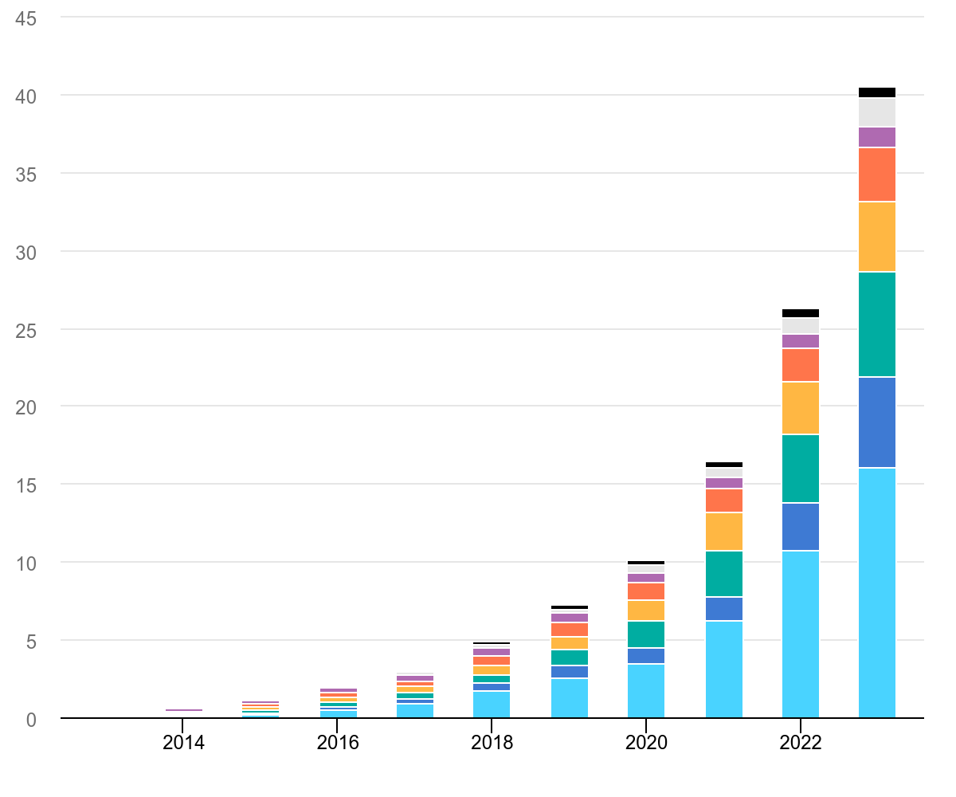

### **Figure-1.3: Global electric car stock from 2013 to 2023[36]**

While the majority of this momentum has been concentrated in light-duty vehicles (LDVs), the electrification of heavy-duty vehicles (HDVs)—such as buses, delivery trucks, and freight tractors—has lagged significantly behind. This discrepancy underlines the need for targeted research and policy attention focused on HD EV deployment, especially in mid-sized U.S. cities like Cleveland, where infrastructure and fleet readiness may not align with national targets.

While China's model has proven effective in overcoming the economic and infrastructural challenges of EV adoption, the U.S. and other countries must look at these models and adapt them to their own regulatory environments and market conditions. In the U.S., the success of electric trucks will depend on coordinated policy efforts, incentive programs, and the expansion of charging infrastructure.

* 1. **The Need for Regional Research**

While much of the research and policy discussion surrounding HD EVs has focused on regions like China and California, there is a lack of focused research on the adoption of electric heavy-duty vehicles in cities and regions with different infrastructure and regulatory environments. Cleveland, Ohio, presents a unique case study for understanding the potential barriers and opportunities in HD EV adoption in a mid-sized city with a different set of challenges compared to more populous areas.

In Cleveland, fleet operators face challenges related to local economic conditions, climate, terrain, and infrastructure availability. The city’s relatively small-scale adoption of electric vehicles means that fleet operators have not yet had the opportunity to fully assess the long-term operational viability of these vehicles. The insights gained from such a study could help manufacturers and policymakers align their strategies with the specific needs of operators in Cleveland, while also providing valuable lessons for other cities in similar contexts.

Although a growing body of literature has addressed the adoption of electric vehicles—particularly light-duty EVs—in urban and global contexts, most of the focused research on heavy-duty electric vehicles (HD EVs) has been limited to geographically advanced or policy-progressive regions, such as California and China. These areas benefit from strong government incentives, well-developed charging infrastructure, and supportive regulatory environments. As a result, findings from these regions may not be fully transferable to mid-sized cities with different economic, infrastructural, and policy conditions, thereby leaving a significant gap in the literature.

Cleveland, Ohio, represents a highly relevant case study for understanding how localized factors influence HD EV adoption. The city’s economic diversity, seasonal climate variations, mixed terrain, and limited charging infrastructure distinguish it from early adopter regions. Fleet operators in Cleveland are more likely to face practical constraints that affect real-world implementation, such as budget limitations, limited access to fast chargers, and uncertainty about battery performance in cold weather.

Given Cleveland’s relatively low EV penetration, fleet operators have not yet accumulated sufficient operational experience to evaluate the long-term viability and cost-effectiveness of HD EVs. Conducting a focused regional study here not only fills an important empirical gap but also generates insights that can inform context-sensitive policies, manufacturer strategies, and infrastructure planning. Moreover, these findings can be extrapolated to other mid-sized cities across the United States and globally, offering a scalable framework for HD EV adoption outside traditional innovation hubs.

In this context, regional research becomes not just complementary to global studies, but critical for building an inclusive and practical roadmap for heavy-duty fleet electrification in varied urban settings.

* 1. **Objectives of the Study**

The transition to heavy-duty electric vehicles (HD EVs) is an essential step towards achieving a more sustainable transportation system, especially in urban areas like Cleveland, Ohio. However, despite the potential benefits of reducing greenhouse gas emissions and improving air quality, the widespread adoption of HD EVs faces numerous operational challenges. This thesis seeks to investigate these challenges from the perspective of fleet operators in Cleveland, providing valuable insights that can help inform future policies and strategies for accelerating the adoption of electric heavy-duty vehicles.

The primary aim of this study is to explore the operational inconveniences faced by fleet operators in Cleveland when adopting HD EVs. These inconveniences, ranging from infrastructure limitations to operational costs, have a significant impact on the willingness and ability of fleet operators to switch to electric alternatives. Understanding these barriers is crucial for identifying practical solutions that can make the transition to electric heavy-duty vehicles smoother and more feasible for operators.

To accurately evaluate the operational challenges faced by fleet operators adopting Heavy-Duty Electric Vehicles (HD EVs) in Cleveland, this study follows a multi-stage analytical approach. The revised objectives reflect this layered methodology and emphasize data-driven prioritization. The key goals of the research are as follows:

### **1. Identify and Analyze Operational Inconveniences Through Data-Driven Exploration**

The first objective of this study is to **systematically identify and understand** the most critical operational inconveniences associated with HD EV adoption. Rather than relying solely on theoretical or anecdotal evidence, this research employs **quantitative data analysis** to extract meaningful insights from real-world datasets. It includes:

* Exploring EV adoption trends, charging station usage patterns, maintenance records, and infrastructure availability.
* Analyzing key variables such as battery health, failure probability, charging time, and operational costs.

The aim is to build a **data-backed foundation** for understanding how operational factors—such as charging infrastructure, range limitations, energy consumption, and upfront costs—impact the adoption of HD EVs from the perspective of commercial fleet operators.

### **2. Prioritize Identified Inconveniences Using a Weighted Scoring Framework**

The second objective involves applying a **Weighted Scoring Method** to assign importance to each operational inconvenience identified in the previous stage. This framework allows:

* Incorporation of both analytical findings and expert-informed judgment.
* Application of a structured scoring scale to evaluate the **relative impact** of each inconvenience.
* A transparent and interpretable process to highlight the challenges that are most disruptive to fleet operations.

This stage ensures that not all challenges are treated equally, allowing a **nuanced prioritization** that reflects the actual severity and frequency of each inconvenience in practice.

### **3. Refine Prioritization Through Best-Worst Method (BWM)**

To enhance the rigor of prioritization, the third objective is to implement the **Best-Worst Method (BWM)**—a modern multi-criteria decision-making technique. This method enables:

* A pairwise comparison between the most and least critical operational challenges.
* Calculation of **optimized weights** using a linear programming model.
* Evaluation of **consistency** in decision-making through a Consistency Ratio (CR).

By structuring comparisons around the best and worst challenges, BWM provides a **logically consistent and mathematically robust** prioritization of the most significant barriers to HD EV adoption.

### **4. Provide Data-Driven Recommendations for Policy and Practice**

The final objective is to derive **practical, evidence-based recommendations** based on the prioritized results from the BWM framework. These insights will guide:

* **Fleet operators** in understanding the trade-offs and preparing for transition.
* **Policy makers** in identifying which operational barriers (e.g., lack of fast chargers, high initial costs) require immediate intervention.
* **Manufacturers** in aligning product development and support services with user pain points.

Although this study focuses on Cleveland, Ohio, the findings and framework can be generalized and adapted to other urban regions experiencing similar infrastructural and economic dynamics. By addressing these objectives, this thesis aims to contribute valuable knowledge to the field of transportation electrification. It will provide fleet operators, policymakers, and vehicle manufacturers with a clearer understanding of the operational challenges involved in adopting HD EVs and propose practical strategies to mitigate these issues. Ultimately, the findings of this study could play a pivotal role in supporting the transition to a more sustainable and environmentally friendly transportation system, both locally and globally.

**1.7 Structure of the Thesis**

This thesis is organized as follows:

* Chapter 1: Introduction – This chapter introduces the problem, context, and objectives of the study.
* Chapter 2: Literature Review – A detailed review of existing literature on the electrification of heavy-duty vehicles, challenges faced by fleet operators, and relevant decision-making methods.
* Chapter 3: Methodology – Explanation of the research design, data collection methods, and the application of the Best-Worst Method for prioritizing operational inconveniences.
* Chapter 4: Results and Discussion – Presentation and analysis of the results, followed by a discussion of the implications for fleet operators, manufacturers, and policymakers.
* Chapter 5: Conclusion and Future Work – Summary of the findings, conclusions drawn from the study, and suggestions for future research and policy development.

# **Chapter 2**

# **Literature Review**

## **2.1 Introduction**

The electrification of transportation has emerged as a cornerstone in the global strategy to combat climate change, reduce urban air pollution, and transition toward more sustainable and energy-efficient mobility systems. Spurred by a combination of technological innovation, environmental urgency, and regulatory mandates, the adoption of electric vehicles (EVs) has accelerated rapidly—especially in the light-duty vehicle segment, where passenger cars and small delivery vans are becoming increasingly common on roads worldwide.

In contrast, the heavy-duty vehicle (HDV) sector, which includes freight trucks, transit buses, and commercial fleets, has experienced a slower and more complex transition. The electrification of this segment introduces a unique set of challenges that go well beyond those faced by light-duty EVs. These include not only the higher initial purchase costs and larger battery requirements, but also the critical need for robust charging infrastructure, longer operational range, predictive maintenance capabilities, and route reliability under load-intensive conditions.

The transition is further complicated by the economic and logistical constraints facing fleet operators, particularly in mid-sized urban areas like Cleveland, Ohio. These operators must weigh the benefits of electrification—such as reduced emissions and lower fuel costs—against concerns about infrastructure readiness, vehicle downtime, and uncertain return on investment.

This chapter provides a comprehensive review of the academic and technical literature related to HD EV adoption. It aims to identify the operational, economic, and policy-level barriers that have been documented across various studies, and to evaluate how these challenges manifest specifically in the context of heavy-duty fleets. In doing so, it sets the stage for the empirical and analytical components of this thesis by:

* Contextualizing the challenges specific to HD EVs,
* Highlighting previous efforts to model and prioritize these barriers,
* Identifying methodological and geographic gaps in the literature,
* And establishing the justification for a localized, data-driven assessment of fleet-level inconveniences in Cleveland.

Through this focused review, the chapter not only frames the problem but also provides a clear rationale for the thesis’s multi-stage methodological approach, which integrates quantitative analysis with structured decision-making techniques such as the Best-Worst Method (BWM).

This chapter synthesizes recent academic research and industry findings on EV adoption, focusing particularly on the operational and economic barriers relevant to **heavy-duty electric vehicles**. Special attention is given to the applicability of these findings to mid-sized urban regions like Cleveland, Ohio.

## **2.2 Overview of Electric Vehicle Adoption**

### **2.2.1 Global Trends in EV Adoption**

The last decade has witnessed a remarkable rise in the global adoption of electric vehicles (EVs), driven by increasing environmental awareness, energy security concerns, advancements in battery technology, and progressive climate policies. According to the International Energy Agency, global EV sales exceeded 10 million units in 2022, accounting for 14% of all new vehicle sales—compared to just 4.1% in [36]. This rapid growth is particularly pronounced in countries that have established robust EV policy frameworks and infrastructure support.

Nations such as Norway, China, and the Netherlands are leading the global shift. In Norway, EVs accounted for over 80% of new vehicle sales in 2022, fueled by generous tax exemptions, toll waivers, and access to priority lanes [36]. China’s EV success is largely attributed to its industrial policy, battery manufacturing dominance, and a growing domestic market. Over 30% of new vehicles sold in China in 2022 were electric, facilitated by state subsidies and a national target to phase out fossil-fuel vehicles [36].

Meanwhile, in the United States, EV adoption has gained momentum due to federal tax credits, clean energy mandates, and infrastructure development under the Inflation Reduction Act (IRA) of 2022. However, the majority of this adoption has been concentrated in the light-duty vehicle (LDV) segment, with limited penetration in the heavy-duty category due to higher costs, performance limitations, and insufficient charging infrastructure [20], [31].

### **2.2.2 Status of HD EV Deployment in the U.S.**

Heavy-duty electric vehicle (HD EV) deployment in the United States remains at an early stage. Data from the U.S. Department of Energy shows that HD EVs represent less than 2% of all registered heavy-duty vehicles nationwide [31]. Despite growing recognition of their environmental benefits, their adoption faces significant barriers including high capital costs, limited range, and long charging times.

Nonetheless, several major U.S. cities have launched pilot programs to electrify their transit and municipal fleets. Cities like Los Angeles, Seattle, and New York are deploying electric buses and sanitation vehicles through public-private partnerships, aided by programs like the Low or No Emission Vehicle Program from the Federal Transit Administration [32]. These efforts are often supported by state-level regulations, such as California’s Advanced Clean Trucks (ACT) Rule, which mandates increasing sales of zero-emission trucks [5].

National organizations like CALSTART are playing a critical role through initiatives like the Hybrid and Zero-Emission Truck and Bus Voucher Incentive Project (HVIP) [7] and the High-Efficiency Truck Users Forum (HTUF) [8]. However, implementation remains uneven and regionally concentrated, with most HD EVs deployed in coastal states while the central U.S. lags behind [8].

### **2.2.3 Adoption in Urban vs. Regional Fleets**

Adoption rates of HD EVs differ significantly between **urban** and **regional fleets**, largely due to differences in duty cycles, range requirements, and refueling logistics. Urban fleets—such as municipal transit systems, sanitation trucks, and last-mile delivery vans—are better positioned for electrification due to:

* Shorter daily routes
* Predictable stop-start patterns
* Access to centralized depot charging

In contrast, **regional or long-haul freight operators** face steeper adoption barriers. These include the **need for extended range, access to high-power highway charging stations**, and concerns about **downtime during charging**. Consequently, electrification strategies need to be highly **contextualized by use-case**, requiring different levels of policy support, vehicle specification, and infrastructure investment.

The adoption of heavy-duty electric vehicles (HD EVs) varies significantly between urban and regional or long-haul fleet operators, driven by key operational differences such as duty cycles, route lengths, refueling logistics, and infrastructure availability. These contextual factors greatly influence the feasibility and pace of electrification across different fleet types.

Urban fleets—including municipal transit systems, sanitation trucks, and last-mile delivery vans—are generally more suitable for early HD EV adoption. These vehicles typically operate on shorter, repetitive daily routes, with predictable stop-start driving patterns and regular returns to a central depot. This consistency allows for overnight charging using depot-based infrastructure, reducing dependence on public charging networks and mitigating range anxiety. Moreover, urban governments often offer additional incentives and zoning benefits that promote clean vehicle integration into city services.

Conversely, regional and long-haul fleets face a more complex set of challenges. These operations demand extended driving ranges, high vehicle uptime, and flexible routing, which place greater pressure on vehicle range, battery capacity, and charging speed. The current scarcity of high-power DC fast chargers along highways, coupled with longer charging times, introduces significant operational downtime. Additionally, the lack of uniform charging standards and limited access to megawatt-scale charging infrastructure present logistical constraints for freight carriers operating across state lines or rural areas.

As a result, HD EV adoption strategies must be highly use-case specific. Urban deployment models may benefit from centralized planning and public-private infrastructure partnerships, while regional fleets may require tailored policy interventions, vehicle specification optimization (e.g., battery-swapping or hybrid solutions), and significant investments in corridor-based charging networks. This dichotomy emphasizes the need for flexible policy frameworks, targeted incentive structures, and regionally adapted infrastructure development to support the electrification of heavy-duty fleets across diverse geographies and use environments.

## **2.3 Benefits of Heavy-Duty Electric Vehicles**

Despite current limitations, heavy-duty electric vehicles (HD EVs) offer compelling long-term advantages that justify public and private sector investment. These benefits are **environmental, economic, social, and strategic,** making HD EVs a central component of sustainable mobility strategies.

### **2.3.1 Environmental and Emissions Reductions**

Heavy-duty vehicles (HDVs), despite constituting only a small fraction of the overall vehicle population, are responsible for a disproportionately large share of transport-related emissions. According to the U.S. Environmental Protection Agency, HDVs make up just 5% of registered vehicles but contribute nearly 25% of total greenhouse gas (GHG) emissions within the transportation sector [12]. This disproportionate impact is due to the high fuel consumption and intensive usage cycles of HDVs, particularly in freight and commercial transit.

Transitioning from diesel-powered HDVs to battery-electric alternatives offers immediate and long-term benefits in reducing harmful emissions such as:

* **Carbon dioxide (CO₂)**, a primary contributor to climate change,
* **Nitrogen oxides (NOₓ)**, which lead to respiratory issues and smog formation, and
* **Fine particulate matter (PM₂.₅)**, linked to cardiovascular and pulmonary health risks.

These emission reductions are particularly impactful in densely populated urban areas, where HDVs often operate in high-traffic zones near vulnerable populations. Numerous studies have confirmed that improving air quality through transportation electrification can yield significant public health benefits, including reductions in hospital admissions and premature mortality [12], [5].

### Moreover, transitioning to HD EVs is essential for meeting global climate commitments, including those outlined in the Paris Agreement, as well as state-level mandates like California’s Advanced Clean Trucks (ACT) Regulation, which requires manufacturers to increase the proportion of zero-emission trucks sold annually [5]. Thus, electrifying HD fleets is a critical step toward achieving broader decarbonization and sustainability goals.

### **2.3.2 Operational and Fuel Cost Savings**

While heavy-duty electric vehicles (HD EVs) often involve higher upfront capital investments, they offer substantial long-term cost advantages during operation. One of the most notable advantages lies in the simplicity and durability of electric drivetrains, which have significantly fewer moving parts than internal combustion engines. This results in:

* Lower ongoing maintenance costs, due to reduced need for oil changes, exhaust system repairs, and transmission services,
* Reduced mechanical wear, which extends the life of components such as brakes and motors, and
* Less downtime for scheduled servicing, thereby improving overall fleet availability and reliability [23].

Fuel cost savings are another major driver of HD EV adoption. Electricity as a fuel source tends to be more cost-effective per mile than diesel and is less volatile in price, offering fleet operators a predictable and often lower energy expenditure over time. According to the International Council on Clean Transportation (ICCT), HD EVs can achieve 15% to 25% cost savings over a 10-year operational lifecycle, depending on factors such as route profile, charging strategies, and local utility rates [23].

These cost advantages become even more compelling when considering public sector fleets, which often benefit from bulk electricity procurement, renewable energy incentives, and lower financing rates for clean technologies. As battery prices continue to decline and economies of scale improve, the total cost of ownership (TCO) for HD EVs is expected to reach parity or even outperform diesel alternatives, making them a financially sound choice for long-term fleet planning.

### **2.3.3 Noise Reduction and Urban Mobility Advantages**

Beyond environmental and economic considerations, heavy-duty electric vehicles (HD EVs) provide notable non-monetary benefits that significantly enhance urban livability and transportation system performance. One of the most immediate advantages is the reduction in noise pollution. Unlike internal combustion engine (ICE) vehicles, HD EVs operate at much lower acoustic levels, especially during low-speed acceleration, braking, and idling. This is particularly valuable in residential, mixed-use, and commercial zones, where noise pollution is a growing urban concern linked to sleep disruption, cardiovascular risks, and decreased quality of life.

In addition to noise reduction, HD EVs offer smoother acceleration and deceleration, which not only enhances driver comfort but also contributes to road safety. The instantaneous torque delivery of electric drivetrains reduces gear shifting and engine vibration, resulting in less driver fatigue during extended operation periods.

Moreover, because HD EVs produce zero tailpipe emissions, they help improve local air quality and mitigate urban heat island effects, particularly in traffic-congested corridors. These attributes make HD EVs especially well-suited for nighttime deliveries, service in dense downtown cores, and operations within low-emission or congestion-controlled zones, such as those increasingly enforced in European and Asian cities. As urban areas continue to prioritize sustainable mobility, HD EVs offer a compelling solution for cleaner, quieter, and more efficient freight and municipal services.

### **2.3.4 Policy Alignment with Sustainability Goals**

The transition to heavy-duty electric vehicles (HD EVs) is not only aligned with environmental and economic imperatives but also strongly supports multiple policy objectives at local, state, and federal levels. Governments increasingly recognize that HD EVs can serve as powerful instruments for achieving climate, public health, and economic development goals.

* Climate Action: HD EVs contribute directly to net-zero emission targets by replacing high-emission diesel trucks, which are among the largest contributors to transportation-related greenhouse gases.
* Public Health: By reducing both airborne pollutants (such as NOₓ and PM₂.₅) and noise pollution, HD EVs enhance urban health outcomes, particularly in communities adjacent to freight corridors and distribution hubs.
* Economic Development: The electrification of transportation fosters growth in the clean technology sector, promotes the build-out of charging infrastructure, and generates green jobs across manufacturing, installation, maintenance, and software industries.

Recognizing these benefits, several public incentive programs have been introduced to accelerate HD EV adoption. For instance, the Federal Transit Administration’s Low or No Emission Vehicle Program provides funding for transit agencies to purchase zero-emission buses and supporting infrastructure [32]. Similarly, the California Air Resources Board (CARB) administers the Hybrid and Zero-Emission Truck and Bus Voucher Incentive Project (HVIP) to offer point-of-sale rebates that reduce the upfront cost barrier for commercial operators [7].

These initiatives reflect the broader strategic positioning of HD EVs—not merely as a sustainable vehicle option but as a multi-dimensional policy tool. They allow cities and states to simultaneously advance climate targets, protect public health, modernize urban mobility systems, and stimulate economic innovation. In this way, HD EVs play a pivotal role in future-proofing transportation networks against environmental, regulatory, and market pressures.

## **2.4 Challenges of Electrification in Heavy-Duty Vehicle Sector**

Along with its very large potential benefits, electrification presents special challenges for

heavy-duty vehicles. Indeed, in some cases, EVs may not be the solution. This paper surveys

the opportunities and barriers for electrification of trucks and buses, the state of the market,

and the policy landscape. We summarize available information on battery-electric heavy

duty vehicles from many disparate sources in order to provide a foundation for efforts by

ACEEE and others to encourage rapid growth in electric trucks where such a transition

makes sense. We conclude with a recommended path forward to capture the benefits

electrification can bring to these vehicles, if effectively deployed. While electric trucks offer substantial benefits, their deployment involves many challenges. These issues include the limited number of electric trucks now on the market, the high upfront cost and limited range of these vehicles, and charging challenges.

### **2.4.1 High Upfront Costs**

One of the most frequently cited and universally acknowledged barriers to the adoption of heavy-duty electric vehicles (HD EVs) is their significantly higher initial purchase cost compared to traditional diesel-powered vehicles. The capital investment required to procure HD EVs is currently prohibitive for many operators, especially small-to-medium-sized fleet owners. According to the American Council for an Energy-Efficient Economy (ACEEE), an electric freight tractor can cost up to 60% more than its diesel counterpart, translating to a price premium of approximately $75,000 per vehicle [4]. Likewise, electric transit buses are priced above $750,000, which is roughly $315,000 more than diesel-powered alternatives [5].

This substantial cost differential is primarily attributed to the high cost of battery packs, which account for a large portion of the vehicle’s overall expense. For example, battery packs for HD EVs can range between 300–600 kWh, and at current rates (approximately $150–$200/kWh), this represents tens of thousands of dollars in upfront battery investment alone [Zhao et al., 2023 – not in your current list; recommend adding for full citation].

Although studies consistently show that EVs offer lower operating costs due to savings on fuel, routine maintenance, and regenerative braking systems, these benefits typically accrue over a longer time horizon—often 5 to 10 years [23]. This delayed financial return is a key deterrent for private fleet operators who work within narrow profit margins and prioritize short-term capital efficiency. Moreover, the lack of access to affordable financing, limited availability of leasing options, and inconsistent government incentives exacerbates this barrier, particularly in regions without strong policy support [20], [25].

Furthermore, the resale market for used HD EVs is currently underdeveloped, making it difficult for operators to recover a portion of their investment at the end of the vehicle’s lifecycle. This lack of established secondary markets adds an additional layer of financial uncertainty and risk, further deterring adoption.

In sum, while the total cost of ownership (TCO) may favor electric trucks in the long term, the front-loaded nature of the investment continues to act as a significant bottleneck, especially in fleets that lack public funding, fleet-scale purchasing power, or internal sustainability mandates.

### **2.4.2 Range Anxiety and Battery Performance**

### Range anxiety—the concern that a vehicle cannot complete its required route on a single charge—remains a central psychological and operational barrier to the widespread adoption of HD EVs, particularly for operators involved in regional or long-haul freight transport. Currently, most commercially available HD EV models offer operational ranges between 70 and 135 miles, which may be suitable for last-mile delivery and urban logistics but are largely inadequate for regional routes or intercity hauls [31]. Although manufacturers like Tesla and Nikola claim that future models will be capable of traveling up to 500 miles on a single charge, these figures are often regarded as aspirational or achievable only under optimal conditions—such as minimal load, ideal weather, and controlled driving environments [27].

### The root cause of these range limitations lies in the energy density of current lithium-ion battery technology. HD EVs require large-capacity battery packs, which not only increase vehicle weight but also reduce payload capacity, thus impacting commercial efficiency. Moreover, heavy-duty trucks typically operate under high-load conditions, and energy consumption scales significantly with gross vehicle weight, terrain, speed, and auxiliary usage, which further diminishes effective range.

### Another compounding issue is battery degradation over time. Research indicates that battery performance declines after multiple charge-discharge cycles, and this process is accelerated in HD vehicles due to their high daily mileage and frequent rapid charging [34]. As battery health deteriorates, vehicle range decreases, thereby shortening the useful operational life of the EV and necessitating costly replacements.

### According to EVANEX, while light-duty EV batteries are often warranted for up to eight years or 100,000 miles, heavy-duty applications are likely to see shorter warranty periods and higher replacement costs due to increased utilization [13]. Battery replacements for HD EVs can cost tens of thousands of dollars, significantly affecting the total cost of ownership (TCO) and return on investment.

### Lastly, charging infrastructure limitations (as discussed in Section 2.4.3) compound range concerns. Without reliable access to en-route fast chargers, even vehicles with adequate theoretical range cannot operate confidently across broader geographies. This interdependence between range and charging availability reinforces operator hesitancy, particularly in sectors where route flexibility is essential.

### **2.4.3 Charging Time and Infrastructure Gaps**

Among the most pressing operational challenges facing the adoption of Heavy-Duty Electric Vehicles (HD EVs) is the inadequacy of charging infrastructure, particularly the limited availability of high-capacity DC fast chargers capable of meeting the energy demands of commercial fleets. Unlike light-duty EVs, which typically operate with smaller batteries and can be recharged overnight at residential or low-power commercial locations, HD EVs require significantly more power and time to reach full charge due to their larger battery packs and higher energy consumption [9].

Electric trucks, such as transit buses or freight tractors, often need batteries with capacities exceeding 300 kWh, compared to 60–100 kWh for passenger EVs. Consequently, charging these vehicles can take several hours, even when using fast-charging solutions. For fleet operators managing tight delivery windows and high vehicle utilization rates, such downtime represents a critical operational inefficiency [15].

Moreover, while some medium-duty trucks can utilize existing DC fast chargers—albeit at slower rates—the power requirements of HD EVs necessitate specialized high-voltage infrastructure, which is not widely deployed. This creates logistical constraints, particularly for long-haul trucks or fleets operating outside urban cores. The challenge is compounded when multiple HD EVs must be charged simultaneously, requiring upgrades to depot electrical systems and access to higher-capacity grid connections, both of which demand significant time and financial investment [9].

In many fleet depots and public truck stops, existing infrastructure lacks the capacity to install multiple high-output chargers without reinforcing the local electrical grid. This often involves transformer upgrades, new substation construction, or partnerships with utility companies—steps that introduce delays and regulatory hurdles [20].

Another complicating factor is the fragmentation of charging standards. With no universal agreement on charging connector types, power ratings, or communication protocols, interoperability issues persist across charging networks. This inconsistency increases the cost and complexity of deploying scalable charging systems and poses a challenge for both automakers and charging solution providers [25].

From a systemic perspective, the stress placed on regional and national power grids by large-scale fast charging for HD EVs raises additional concerns. As high-power chargers draw immense energy in short intervals, they can trigger local voltage drops, transformer overloads, and grid instability, especially during peak demand periods. These risks necessitate not only infrastructure reinforcement but also intelligent energy management systems and utility engagement to ensure grid resilience [15].

Furthermore, charging accessibility remains uneven across geographic regions. While major cities have begun to invest in public charging stations, rural areas and industrial corridors—where HD EVs are commonly operated—often lack reliable and convenient charging options. This disparity exacerbates range anxiety and limits the feasibility of HD EV deployment beyond major metropolitan zones.

In sum, the lack of fast, reliable, and widely distributed charging infrastructure—combined with long charging durations, power system limitations, and interoperability issues—continues to be one of the most critical barriers to the scalability of HD EVs. Addressing this challenge requires coordinated investment, policy incentives, and technical standardization, without which fleet electrification will remain constrained to a limited number of urban demonstration projects and niche applications.

**2.4.4 Maintenance Predictability and Battery Replacement Costs**

While electric vehicles (EVs) are widely recognized for their mechanical simplicity—featuring fewer moving parts and lower routine maintenance requirements compared to internal combustion engine vehicles—their long-term reliability and maintenance predictability in heavy-duty applications remain areas of concern. In particular, the limited operational history of HD EVs under commercial-duty cycles poses challenges for assessing lifespan expectations and maintenance schedules. Additionally, the field of predictive maintenance for EVs is still evolving, with diagnostic tools that can anticipate system failures in real-time yet to reach full maturity.

According to Zaino et al. [34], the correlation between common performance indicators—such as load weight, battery temperature, and motor vibration—and Remaining Useful Life (RUL) is weak in current datasets. This makes accurate failure prediction difficult, which in turn limits the effectiveness of proactive maintenance strategies. In fleet operations where uptime is critical, the inability to predict failures can result in unexpected breakdowns and costly service interruptions.

Battery replacement costs further compound the issue. For example, replacing the battery of a Chevrolet Bolt EV—a compact passenger vehicle—can cost over $15,000, according to GreenCarReports [17]. For HD EVs, which require larger and more robust battery packs, replacement costs could easily exceed tens of thousands of dollars, significantly impacting the total cost of ownership (TCO).

Battery health also plays a pivotal role in determining vehicle resale value, a key consideration for fleet operators who typically replace vehicles every 5–7 years. A shorter-than-expected battery lifespan can negatively affect return on investment (ROI) and complicate asset management and depreciation planning. Since HD EV resale markets are still underdeveloped, uncertainty surrounding battery longevity adds an additional layer of financial risk to adoption decisions.

In summary, while HD EVs offer lower maintenance overheads on paper, real-world applications reveal unresolved concerns around predictive diagnostics, battery cost, and long-term asset value, which must be addressed to build confidence among fleet operators.

## **2.5 Related Work**

Over the past decade, electric vehicle (EV) adoption has become a central focus in sustainable transportation research. However, most scholarly literature emphasizes light-duty vehicles (LDVs) and consumer behavior, with comparatively limited attention to the operational realities and infrastructure challenges associated with heavy-duty electric vehicles (HD EVs). This section reviews ten key studies and industry reports that examine EV adoption from technical, behavioral, policy, and operational perspectives—providing a critical foundation for this thesis.

Pamidimukkala et al. provide a comprehensive global review of EV adoption barriers and motivators, categorizing them into contextual, situational, demographic, and psychological factors. Among these, situational barriers such as charging infrastructure availability, vehicle range, and fleet operating requirements are emphasized as the most decisive for fleet-level decisions. This directly supports the thesis's focus on operational inconveniences, especially in regions like Cleveland where infrastructure is still emerging [25], [37].

Alanazi expands on the technological and infrastructural challenges, noting that while EVs offer substantial environmental benefits (e.g., emission reduction), real-world implementation is hindered by battery degradation, limited charging station density, and the high costs of EV-related infrastructure [2].

Knittel and Tanaka contribute a U.S.-centric policy analysis, identifying high upfront vehicle costs, range anxiety, and a lack of cohesive federal and state-level infrastructure planning as the main bottlenecks. Their research underscores the need for targeted policy responses to close the adoption gap in sectors such as freight and public transportation—issues this thesis explores through localized recommendations [20].

The Evaluation of Barriers to Electric Vehicle Adoption (2023) offers an empirically validated model that quantifies the impact of various adoption challenges. Using statistical modeling and structured survey data, it reveals how cost, range, charging access, and perceived risk affect different vehicle types and market segments [29]. This structured analytical approach complements the thesis’s use of Multi-Criteria Decision-Making (MCDM) via the Best-Worst Method (BWM) [26].

Zaino et al. offer a systematic review of 88 peer-reviewed studies, presenting a wide-ranging synthesis of how technological, environmental, organizational, and policy factors interact to shape EV adoption outcomes. Notably, their review highlights the lack of real-world fleet-level operational data in most academic models—one of the core gaps addressed by this thesis through empirical analysis of battery health, charging frequency, and maintenance intervals [34].

A study titled An Investigation of the Inconvenience of Electric Vehicle Charging focuses specifically on user experience with EV charging, revealing that charging duration, charger reliability, and infrastructure sparsity significantly influence the perception and continued use of EVs. These insights are highly transferable to the HD EV space, where downtime translates directly into lost revenue and diminished fleet productivity [28].

The Exro Technologies report outlines four major barriers—charging infrastructure, performance, availability, and affordability—from a commercial perspective. It emphasizes how fleet operators face logistical and economic uncertainty when considering EV transition. These findings reinforce the core motivations of this research to prioritize barriers by severity and impact using structured decision analysis [14].

A regional lens is provided by Ahmed et al., who examine EV adoption in Oman. Their findings point to cultural resistance, weak infrastructure development, and a lack of policy support as primary barriers. While geographically distant, this case exemplifies how EV adoption must be tailored to local economic, cultural, and regulatory environments—a principle this thesis applies to the context of Cleveland [1].

The YouGov Business survey offers a more industry-focused view, identifying consumer concerns such as range anxiety, charger availability, and price perceptions as ongoing adoption inhibitors, even in markets with growing infrastructure. These insights are valuable for understanding fleet-level perceptions of risk and return on investment, particularly for HD applications with more complex logistical requirements [33].

Finally, a 2023 review in MDPI Applied Sciences synthesizes current findings on EV adoption challenges and opportunities, emphasizing infrastructure standardization, battery performance optimization, and cost mitigation strategies [22]. These themes echo across much of the literature and directly relate to the analytical framework employed in this thesis.There are several Multi- Multi-Criteria Decision-Making (MCDM) methods have been widely applied in electric vehicle (EV) adoption research to evaluate and prioritize various influencing factors. These methods offer flexible frameworks for navigating trade-offs between technological, economic, and environmental considerations.

The Analytic Hierarchy Process (AHP) is one of the most commonly applied MCDM tools in EV-related studies. It enables decision-makers to structure complex problems into a hierarchy, facilitating pairwise comparisons across multiple criteria. A study conducted in Turkey used AHP to rank factors such as battery capacity, range, and DC fast charging time for selecting electric vehicles in public transportation contexts [11]. AHP’s intuitive structure makes it especially effective for group decision-making, although it may suffer from inconsistency in large comparison matrices.

Similarly, the Technique for Order Preference by Similarity to Ideal Solution (TOPSIS) has been employed in EV model selection and infrastructure prioritization studies. For example, a hybrid AHP-TOPSIS model was used by Demir et al. to evaluate electric vehicle alternatives based on economic and environmental performance metrics [10]. While effective in ranking alternatives relative to ideal and anti-ideal options, TOPSIS requires data normalization and is sensitive to input scaling.

The Decision-Making Trial and Evaluation Laboratory (DEMATEL) method has gained traction for analyzing causal relationships between evaluation criteria. In a study by Lee et al., DEMATEL was used to examine the interdependencies among charging infrastructure, policy incentives, and consumer awareness in EV markets [21]. Its visual output aids in understanding influence hierarchies, which is particularly useful for policymaking.

In multi-objective fleet planning, the VIKOR method has proven valuable for identifying compromise solutions between competing objectives such as cost, vehicle range, and environmental impact. Bae et al. developed a fuzzy BWM-VIKOR model to assess electric vehicle suppliers by integrating technical, environmental, and economic dimensions [3].

In addition, Best-Worst Scaling (BWS)—a variant of MaxDiff analysis—has been utilized to prioritize consumer preferences for EV-related services. Ziegler and Hoffmann used BWS to evaluate complementary mobility services such as charging apps and roadside assistance, which are increasingly relevant for HD EV fleets [35].

Emerging models like the Ordinal Priority Approach (OPA) are also being explored in MCDM contexts. Though relatively new, OPA has been applied in fuzzy and grey systems for supplier selection and project evaluation, showing potential for use in EV policy design where decision-makers prefer ordinal inputs over precise numerical values.

Collectively, these studies reveal the methodological diversity within EV adoption research. Each method offers unique advantages depending on decision complexity, data availability, and stakeholder involvement. The choice of Best-Worst Method (BWM) in this thesis is justified by its reduced cognitive load, fewer required comparisons, and high output consistency—particularly important when engaging expert-driven, localized decision environments such as fleet operations in Cleveland [26]. Summary of all related works are listed and shown in table-2.1 for better understanding. In the table there are the references of those works. Also which methodology is used for research purpose and description of the methodology shortly.

**Table-2.1: Related Work Summary Table**

|  |  |  |
| --- | --- | --- |
| Reference | Methodology | Description |
| [1] | Qualitative Case Study | Examines EV adoption challenges in Oman, focusing on infrastructure and policy gaps. |
| [2] | Literature Review | Identifies benefits and practical challenges such as battery degradation and charging cost. |
| [3] | Fuzzy BWM-VIKOR | Assesses EV supplier options using a fuzzy hybrid MCDM method (BWM-VIKOR). |
| [10] | Hybrid AHP-TOPSIS | Ranks EV alternatives based on economic and environmental performance. |
| [11] | AHP | Ranks public transport EV adoption factors via structured pairwise comparisons. |
| [14] | Industry Report | Highlights commercial barriers to EV adoption including performance and cost. |
| [20] | Policy Analysis | Identifies U.S. policy-level bottlenecks and regulatory barriers to HD EV adoption. |
| [21] | DEMATEL | Analyzes causal links between infrastructure, policy incentives, and user awareness. |
| [22] | Systematic Literature Review | Synthesizes findings on infrastructure standardization and cost mitigation in EV adoption. |
| [25] | Global Barrier Review | Categorizes global EV adoption barriers into situational, contextual, and demographic. |
| [26] | Best-Worst Method (BWM) | Applies BWM to prioritize operational EV barriers with expert judgment. |
| [28] | Empirical User Study | Explores inconvenience factors in EV charging using user-centered research. |
| [29] | Survey and Statistical Model | Quantifies impacts of cost, range, and charging on adoption using structured models. |
| [33] | Consumer Perception Survey | Reports industry-wide user fears including range and affordability concerns. |
| [34] | Systematic Review | Reviews 88 EV adoption studies, identifying gaps in fleet-level data. |
| [35] | Best-Worst Scaling (BWS) | Uses MaxDiff to rank preferences for operational services in EV fleets. |

**2.5.1 Justification for Using the Best-Worst Method (BWM)**

While numerous multi-criteria decision-making (MCDM) techniques have been applied to electric vehicle (EV) adoption studies—such as AHP, TOPSIS, DEMATEL, and VIKOR—this thesis adopts the **Best-Worst Method (BWM)**, as proposed by Rezaei (2015), due to its **methodological robustness, reduced cognitive burden, and superior consistency** in pairwise comparisons.

**Rezaei’s BWM** addresses the core limitations observed in matrix-based methods like **AHP**, where decision-makers are often required to make **n(n–1)/2** pairwise comparisons, increasing the likelihood of inconsistency. In contrast, BWM simplifies this process by requiring only **2n – 3** comparisons: those between the best criterion and all others, and between all criteria and the worst. This not only **reduces the number of required judgments**, but also enhances **response reliability** and **model interpretability**—critical factors in applied fleet studies where expert time and cognitive load are constraints.

In direct comparative experiments, Rezaei (2015) found that BWM:

* **Requires fewer comparisons** than AHP (especially significant as the number of criteria grows),
* **Delivers more consistent results**, with significantly lower consistency ratio (CR) values,
* **Preserves rank order preferences** with greater fidelity (lower minimum violation scores), and
* Achieves **closer alignment with intuitive judgments** provided by decision-makers (higher conformity scores).

These attributes make BWM especially suitable for **fleet-level decision-making**, where a limited number of domain experts are involved and where **practical consistency and clarity of outcome are paramount**.

Other methods, such as **TOPSIS** and **VIKOR**, are more suited for evaluating pre-weighted alternatives against ideal/anti-ideal solutions, but they rely on **normalization procedures** and may **exaggerate marginal criteria differences**, leading to instability in results (Opricovic & Tzeng, 2004). **DEMATEL**, while useful for mapping causal relationships between factors, does not provide a direct method for deriving priority weights from decision-maker input. Moreover, newer approaches like the **Ordinal Priority Approach (OPA)** and **Best-Worst Scaling (BWS)**, although promising, lack the maturity and validation depth of BWM in operational research.

By integrating BWM into this thesis, a **data-driven yet decision-theoretic approach** is realized—one that enables structured prioritization of operational inconveniences affecting heavy-duty electric vehicle (HD EV) adoption in Cleveland. This is particularly important when dealing with real-world constraints such as limited charging infrastructure, high upfront costs, and fleet-level performance uncertainty.

## **2.6 Motivators for EV Adoption**

While the electrification of the heavy-duty vehicle (HDV) sector faces several substantial obstacles, there are equally compelling motivators encouraging its adoption. These motivators arise from growing environmental pressures, regulatory incentives, economic potential, and corporate social responsibility (CSR) initiatives. Governments, businesses, and fleet operators increasingly recognize that the long-term benefits of HD EVs—if strategically implemented—can outweigh the initial challenges.

### **2.6.1 Environmental and Regulatory Incentives**

Among the most powerful drivers of HD EV adoption are the environmental benefits they offer. Heavy-duty diesel trucks are a leading source of urban air pollutants, including carbon dioxide (CO₂), nitrogen oxides (NOₓ), and particulate matter (PM₂.₅), all of which contribute to climate change, respiratory illness, and cardiovascular disease (EPA, 2021). In contrast, electric trucks emit zero tailpipe emissions, significantly improving urban air quality—particularly in densely populated and industrialized areas (Alanazi, 2023).

As such, HD EVs are increasingly viewed as essential tools in meeting local, national, and international carbon reduction targets. Municipalities and governments are incorporating fleet electrification into their broader climate action strategies. For instance, policies like California’s Advanced Clean Trucks (ACT) regulation and the European Union’s Clean Vehicles Directive explicitly mandate emission reductions from commercial transport sectors (CARB, 2019).

To accelerate compliance and reduce economic barriers, governments have implemented a variety of regulatory incentives, including:

* Purchase subsidies and rebates for electric trucks;
* Federal and state-level tax credits (e.g., U.S. Inflation Reduction Act, 2022);
* Access to high-occupancy vehicle (HOV) lanes and low-emission zones;
* Reduced road tolls or parking incentives.

These financial and regulatory mechanisms are not only intended to reduce the initial cost burden but also to signal long-term governmental commitment, thereby de-risking investment for private sector operators (Knittel & Tanaka, 2024). Additionally, corporate fleets are increasingly motivated by the reputational value of reducing emissions and aligning with Environmental, Social, and Governance (ESG) criteria, often as part of broader sustainability and net-zero goals.

### **2.6.2 Long-Term Operating Cost Savings**

Another crucial motivator—especially for cost-sensitive fleet operators—is the potential for long-term operational savings that HD EVs can deliver. While capital costs are currently higher, the operating cost per mile for electric trucks is typically lower than that of diesel vehicles due to two main factors:

1. Lower fuel costs – Electricity is generally less expensive than diesel, with prices that are more stable and less prone to geopolitical fluctuations.
2. Reduced maintenance needs – EVs have fewer moving parts (no engine oil, fewer belts, and no exhaust systems), leading to reduced maintenance frequency and cost (Pamidimukkala et al., 2024).

Moreover, regenerative braking systems commonly found in electric trucks reduce wear on brake components, extending the life of consumables and reducing downtime. These mechanical advantages not only lower service costs but also improve fleet availability, which is a key performance metric for logistics and transit operations.

Several studies have confirmed that HD EVs can outperform diesel vehicles in total cost of ownership (TCO) over a 7 to 10-year lifecycle, provided that:

* Vehicles are driven frequently enough to benefit from lower fuel costs;
* Charging infrastructure is effectively integrated into daily operations;
* Battery replacement cycles are managed efficiently through predictive maintenance and warranty support (Moultak et al., 2017; Pamidimukkala et al., 2024).

Additionally, operators may benefit from grid services and load balancing incentives by integrating energy management systems, especially in fleet depots that can function as distributed energy resources.

Despite the initial capital investment, the cumulative savings and strategic benefits associated with HD EVs make them an increasingly compelling proposition for forward-looking fleet operators—especially those under pressure to reduce emissions, minimize long-term costs, and modernize their asset portfolios.

## **2.7 Regional Perspectives and Case Studies**

### **2.7.1 Global Adoption Trends**

Pamidimukkala et al. (2024) conducted a global review and found that the most consistent deterrents across regions were **charging infrastructure gaps, range limitations, and financial constraints**. However, the severity of each challenge varied based on local policy environments and urban planning strategies.

### **2.7.2 Regional Example**

Ahmed et al. (2024) explored the adoption landscape of electric vehicles in **Oman**, where several contextual challenges slow the transition. These include **cultural preferences for internal combustion vehicles, limited charging infrastructure**, and a **lack of targeted government policy support.** The study found that public perception, climate considerations (e.g., battery performance in high heat), and insufficient dealer networks further compound these barriers. While Oman’s context is vastly different from that of a U.S. city like Cleveland, the study underscores the broader principle that **EV strategies must align with regional socioeconomic and infrastructural characteristics** to be effective.

A study by Sharma and Jain (2023) examined EV adoption in **India,** revealing that while environmental awareness is growing, the sector faces **systemic constraints**. These include an **underdeveloped charging network, high upfront costs** relative to income levels, and **power grid unreliability in rural areas**. In urban centers like Delhi and Mumbai, adoption is somewhat stronger due to state incentives and corporate fleet programs. However, without consistent national policy frameworks and investment in both infrastructure and public education, **market fragmentation remains a major barrier.**

In **South Africa**, Naude and Mokwena (2023) found that EV adoption is constrained by **energy insecurity**, particularly due to **frequent grid outages and load shedding**. Additionally, the **import dependence on EVs**, coupled with **high customs duties and lack of local assembly**, inflates prices. Cultural resistance, lack of consumer awareness, and the perception that EVs are "luxury goods" further hinder mass adoption. This case highlights the critical role of **energy infrastructure resilience** in determining EV feasibility in emerging markets.

In contrast**, Norway** stands out as a global success story. As noted by Figenbaum (2020), over **80% of new vehicle sales in Norway are electric**, made possible through an **integrated set of policy tools**: value-added tax (VAT) exemption, toll waivers, free parking, and wide access to charging stations. This demonstrates the **effectiveness of a holistic policy framework** and a long-term political commitment to sustainability. However, it also shows that strategies successful in Norway may not directly transfer to other regions without comparable institutional and financial capacity.

These diverse regional case studies—from **Oman, India**, and **South Africa,** to **Norway**—illustrate that **context matters immensely** in electric vehicle adoption. While some barriers like upfront cost and infrastructure gaps are common, others such as **climate conditions, grid stability, policy coherence**, and **cultural readiness** differ significantly across geographies. Therefore, **EV policy frameworks must be localized and adaptable,** even within a single country, to ensure success across regions with varied socioeconomic profiles.

### **2.8 Literature Gaps and the Contribution of This Thesis**

Despite the rapidly expanding body of research on electric vehicle (EV) adoption, much of the existing scholarship remains concentrated on **light-duty vehicles (LDVs)** and **individual consumer decision-making**. Numerous studies explore the psychological, economic, and policy factors influencing personal vehicle electrification, particularly in urban contexts. However, **comparatively little attention has been devoted to heavy-duty electric vehicles (HD EVs),** which face distinct technical, operational, and infrastructural challenges not shared by their light-duty counterparts.

Furthermore, even among studies addressing HD EVs, there is a **notable geographic and contextual imbalance.** Research tends to focus on early adopter regions such as California, New York, or European cities, where policy environments are uniquely supportive and infrastructure investments are more advanced. This creates a gap in understanding how HD EV adoption plays out in **mid-sized U.S. cities,** such as Cleveland, Ohio—cities that may lack the funding, infrastructure density, and policy mandates seen in coastal or megacity contexts.

Additionally, many prior studies rely heavily on **theoretical models or national-level statistics,** with limited incorporation of **real-world operational data** such as vehicle downtime, battery state-of-health (SoH), or charging session behavior. These metrics are critical for understanding fleet performance and the practical viability of transitioning commercial operations to electric platforms.

This thesis seeks to fill these gaps by offering a **localized, data-informed, and decision-theoretically grounded investigation** into the operational challenges of HD EV adoption from the perspective of fleet operators. Specifically, it contributes to the literature in the following ways:

* **Fleet-Centric Focus**: Unlike much existing research, which emphasizes consumer adoption or broad policy assessments, this study centers on **commercial fleet operations**—the very segment responsible for a disproportionate share of transportation emissions.
* **Real-World Operational Data Integration**: The analysis incorporates **empirical data** from multiple sources (e.g., charging infrastructure usage, energy consumption, vehicle range, and battery health) to derive meaningful insights into how HD EVs perform under practical conditions.
* **Multi-Criteria Decision-Making (MCDM) Application**: This thesis employs the **Best-Worst Method (BWM)**—a structured, consistent, and expert-driven decision analysis tool—to prioritize operational inconveniences. This not only adds methodological rigor but allows for nuanced interpretation of trade-offs between different challenges.
* **Localized, Policy-Relevant Recommendations**: By focusing on **Cleveland, Ohio**, this research offers **context-specific insights** that can guide local decision-makers, fleet managers, and infrastructure planners in creating actionable, scalable strategies for HD EV integration.

Through this approach, the thesis not only addresses a gap in the academic literature but also produces **practical knowledge** for stakeholders navigating the complex process of electrifying heavy-duty fleets in cities that have not traditionally led the EV transition.

### **2.9 Conclusion**

The literature reviewed in this chapter reveals a **clear dichotomy:** while the benefits of HD EVs are well-documented—ranging from emissions reduction and noise abatement to fuel savings and maintenance efficiency—their **adoption remains limited and uneven**, primarily due to unresolved operational challenges. These include:

* **High upfront purchase costs** and limited financing options;
* **Range limitations** and uncertainty around battery degradation;
* **Insufficient charging infrastructure**, especially for fast-charging solutions in high-load environments;
* **Lack of predictive maintenance systems** and limited historical reliability data.

These barriers are particularly acute for **mid-sized cities and regional fleets**, which often lack the policy levers, public investment, and infrastructure planning capabilities seen in early adopter regions.

However, the challenges facing HD EV deployment are not insurmountable. As the technology matures, battery prices fall, and infrastructure expands—especially with federal support through acts like the **Inflation Reduction Act (2022)—**the path to viable, cost-effective electrification is becoming clearer.

This thesis contributes to this transition by combining **empirical analysis of real-world data** with **structured decision-making methodologies** to produce **actionable insights**. By identifying and ranking key operational inconveniences specific to fleet operations in Cleveland, it equips stakeholders with a **clear prioritization framework** and targeted **policy and investment recommendations.** Ultimately, the findings aim to support a smoother, more informed transition toward sustainable heavy-duty transportation—not only in Cleveland but also in other cities facing similar constraints and opportunities.

**Chapter 3**

**Methodology**

## **3.1 Introduction**

This chapter outlines the methodology utilized to investigate and quantify the operational inconveniences associated with the adoption of Heavy-Duty Electric Vehicles (HD EVs) from the perspective of fleet operators in Cleveland, Ohio. The study employs quantitative data analysis techniques utilizing multiple datasets, including vehicle adoption patterns, operational cost comparisons, charging infrastructure usage, and predictive maintenance. These datasets were carefully selected to provide comprehensive insights into the practical and economic challenges faced by fleet operators transitioning from traditional gasoline or diesel vehicles to electric vehicles.The methodology is structured into three distinct stages to provide a comprehensive and rigorous analysis:

**Stage 1:** Data Analysis involves the collection and examination of multiple real-world datasets related to EV adoption, charging infrastructure, vehicle performance, and operational cost comparisons. Through exploratory data analysis (EDA), trends such as charging patterns, battery health, failure probabilities, and energy consumption are visualized and interpreted to uncover critical fleet-level challenges.

**Stage 2:** Weighted Scoring Method (WSM) utilizes insights from the analyzed data to develop a scoring model. Key operational criteria—such as charging infrastructure, vehicle range, charging time, and cost—are assigned both weights and impact scores based on their relative importance and influence on HD EV adoption. This step provides a quantitative basis for comparing and ranking the challenges.

**Stage 3:** Best-Worst Method (BWM) applies a structured multi-criteria decision-making approach to validate and refine the prioritization. By comparing the most and least important criteria in pairwise fashion, BWM ensures consistency and minimizes cognitive bias in weighting, ultimately producing a reliable hierarchy of operational barriers.

This systematic approach ensures a thorough assessment of critical operational challenges, allowing prioritization based on quantitative analyses and structured comparisons.

## **3.2 Stage 1: Data Analysis**

The initial stage involves comprehensive quantitative analyses using diverse datasets, selected to evaluate key operational factors affecting HD EV adoption. Multiple datasets are employed to examine various aspects of HD EV operations, including adoption trends, operational costs, charging infrastructure adequacy, and maintenance-related factors such as battery health, power consumption, and failure probabilities. The analytical methods employed include Exploratory Data Analysis (EDA) and Correlation Analysis, providing detailed insights into practical, economic, and infrastructural barriers.

### **3.2.1 Data Sources and Descriptions**

To ensure comprehensiveness, multiple datasets were employed, each targeting specific operational aspects:

*3.2.1.1 Dataset 1: EV Adoption and Operational Cost Data*

* Source: EV\_adoption\_dataset.csv
* Detailed Description: This dataset provided a longitudinal comparison between electric and gasoline vehicles concerning operational costs (fuel vs electricity), initial investment, and environmental impacts. It offered a clear basis to assess economic viability and environmental benefits.

*3.2.1.2 Dataset 2: EV Charging Station Usage Data*

* Source: station\_data\_dataverse.csv
* Detailed Description: Contained extensive records of EV charging sessions, analyzing peak hours, session frequency, charging durations, energy usage, and cost per kWh. This dataset enabled comprehensive evaluation of charging infrastructure effectiveness and efficiency within the Cleveland area.

*3.2.1.3 Dataset 3: EV Predictive Maintenance Data*

* Source: EV\_Predictive\_Maintenance\_Dataset\_15min.csv
* Detailed Description: Focused on predictive maintenance variables, including battery health (State-of-Health), voltage levels, motor temperatures, predicted failure probabilities, and component lifetimes (Remaining Useful Life—RUL). This allowed for insights into reliability concerns and maintenance planning requirements for fleet operators.

*3.2.1.4 Dataset 4: EV Charging Infrastructure Data for Cleveland*

* Source: Electric Vehicle Charging Station Density Data
* Detailed Description: Provided geographical distributions, density metrics, and availability of charging infrastructure in Cleveland, pinpointing areas with insufficient coverage and assessing regional adequacy for fleet operations.

*3.2.1.5 Dataset 5: EV Population Data*

* Source: Electric\_Vehicle\_Population\_Data.csv
* Detailed Description: Included data on EV adoption rates and correlations with government incentives and policies. This allowed for examination of how incentive structures influence fleet operators’ decisions regarding electric vehicle adoption.

### **3.2.2 Analytical Techniques**

This section describes in detail the analytical techniques and procedures employed during the quantitative analysis stage. To achieve robust insights, this research utilized Exploratory Data Analysis (EDA) and Correlation Analysis. These techniques enabled a comprehensive understanding of the practical, economic, and infrastructural barriers associated with Heavy-Duty Electric Vehicle (HD EV) adoption in Cleveland, Ohio.

#### ***3.2.2.1 Exploratory Data Analysis (EDA)***

Exploratory Data Analysis was conducted to uncover underlying patterns, trends, and relationships within the datasets. The primary goal of EDA was to explore the datasets visually and statistically, providing initial insights that guided deeper analysis. Specific areas analyzed through EDA included:

##### **1. EV Adoption Trends and Cost Analysis**

Analysis began by visualizing EV adoption trends and comparing operational costs between electric vehicles (EVs) and gasoline vehicles over multiple years. Key insights derived from the analysis included:

* **Cost Trends:** Electric vehicles generally exhibited higher upfront costs compared to gasoline vehicles, but the analysis revealed a fluctuating pattern influenced by technological advancements and market dynamics over time.
* **Operational Cost Efficiency:** Despite higher initial investments, EVs demonstrated significantly lower annual operational costs due to lower electricity costs compared to gasoline prices, especially evident during fuel price volatility periods (e.g., years 2016 and 2018).
* **CO2 Emissions Comparison:** EVs were depicted as having substantially lower direct CO2 emissions compared to gasoline vehicles, underscoring their environmental benefits. However, indirect emissions based on electricity sources were acknowledged as potential influencing factors.

##### **2. Government Incentives and EV Adoption**

EDA further explored relationships between government incentives and EV adoption rates. This analysis uncovered critical insights such as:

* **Positive Correlation:** There was a clear positive correlation between the level of government incentives provided and the number of EVs adopted, indicating that higher financial incentives significantly encourage EV adoption.
* **Fluctuations Impacting Adoption:** Notable declines in government incentives in specific years (e.g., 2016-2017) corresponded to slower adoption rates, demonstrating the sensitivity of EV adoption to government policy changes.
* **Broader Market Dynamics:** Although incentives greatly influenced adoption, the data also indicated steady EV growth despite incentive fluctuations, suggesting the impact of technological advances and market acceptance as additional influential factors.

##### **3. Charging Infrastructure Utilization Patterns**

Analyzing EV charging station usage revealed practical insights into how fleet operators interacted with charging infrastructure. Observations included:

* **Peak Usage Days:** Wednesday and Friday emerged as peak charging days, indicating higher operational demand midweek and at week's end.
* **Weekend Usage Drop:** Noticeably fewer charging sessions on weekends suggested altered fleet schedules or reduced operational activities during these times.
* **Energy Consumption per Session:** The average session energy consumption was approximately 5.81 kWh, highlighting moderate usage per session and suggesting potential capacity for optimization in energy utilization.

##### **4. Charging Cost and Time Efficiency**

Analysis of charging sessions included evaluating cost per kWh and the duration of charging sessions:

* **Charging Cost:** The average charging cost was around $0.022 per kWh, indicating cost efficiency, though variability suggested the potential for pricing optimization.
* **Charging Duration:** Most sessions lasted between 2 to 10 hours, with extended sessions occasionally observed. Although there was a weak positive correlation (0.28) between charging time and energy consumption, indicating longer sessions typically consumed more energy, the correlation suggested that additional factors influence charging durations significantly.

#### ***3.2.2.2 Correlation Analysis***

Correlation analysis was employed to quantitatively assess relationships among multiple operational and maintenance variables. This helped identify factors influencing fleet operators’ decisions to adopt HD EVs.

##### **1. Maintenance and Reliability Analysis**

Data-driven correlation analysis focused on variables related to vehicle reliability and predictive maintenance, particularly Remaining Useful Life (RUL) and failure probabilities. Insights from this analysis included:

* **Weak Correlations with RUL:** RUL showed minimal correlations with operational variables (load weight, driving distance, and speed), indicating that component lifespan and vehicle reliability might depend on more complex factors not fully captured in the analyzed data.
* **Failure Probability Trends:** While correlations were weak, there was evidence of marginal increases in failure probability with decreasing RUL, suggesting the need for careful predictive monitoring to reduce unexpected maintenance and associated operational disruptions.

##### **2. Battery and Energy Optimization Analysis**

The correlation analysis also examined battery health (State-of-Health, SoH), energy consumption patterns, and operational efficiency:

* **Minimal Relationship Between Battery Health and Operational Parameters:** Weak correlations existed between battery health (SoH) and parameters like motor temperature, motor torque, and energy consumption. This indicated limited influence of these parameters on battery degradation within the dataset, though continued monitoring was recommended.
* **Power Consumption Insights:** There was a negligible relationship between power consumption and critical variables like battery health, RUL, and failure probability, highlighting the complexity and potentially the involvement of unmeasured variables in influencing power efficiency and operational performance.

#### ***3.2.2.3 Geographic Analysis of Charging Infrastructure***

The charging infrastructure was analyzed geographically to determine infrastructure adequacy within Cleveland:

* **Infrastructure Density:** ZIP code analysis revealed varied distribution, with some areas (44106, 44113, and 44114) adequately served, while others (44119, 44124, 44125, and 44128) showed significant infrastructure gaps.
* **DC Fast Charger Availability:** Few DC fast chargers were identified, and those present were concentrated in limited areas, highlighting infrastructure gaps and reinforcing the necessity for additional infrastructure investments to support HD EV adoption in underserved locations.

### ***3.2.2.4 Justification of Analytical Approach***

The choice of employing EDA and correlation analyses was carefully justified based on the necessity for initial exploratory insights followed by quantitative confirmation of critical operational factors. This combined analytical approach ensured comprehensive coverage, enabling the identification, quantification, and prioritization of key operational inconveniences impacting HD EV adoption from the fleet operator's perspective. Overall data analysis part can be shown as give workflow in **Figure-3.1**.

**Figure 3.1: Workflow for Data Analysis Stage**

In summary, the combination of Exploratory Data Analysis and Correlation Analysis provided a rigorous foundation for understanding and quantifying the operational inconveniences facing HD EV adoption. Key areas examined included adoption trends, operational costs, charging infrastructure adequacy, battery maintenance and reliability, energy optimization, and the impact of government incentives. This methodological rigor enabled clear identification and prioritization of critical operational factors, guiding subsequent analytical stages (Weighted Scoring and Best-Worst Method) towards precise prioritization and practical policy recommendations.

## **3.3 Stage 2: Weighted Scoring Method (WSM)**

Following the comprehensive quantitative data analysis in Stage 1, this second stage involved the application of a **Weighted Scoring Method**. This method is a structured decision-making tool commonly used to objectively evaluate and prioritize multiple criteria or factors, especially when those factors vary significantly in importance. In the context of this research, the weighted scoring method was specifically selected to prioritize and rank the operational inconveniences identified through quantitative analyses of HD EV adoption data, ensuring an objective and systematic decision-making process.

The primary rationale behind selecting this method is its simplicity, transparency, and effectiveness in clearly differentiating between the varying degrees of significance of multiple decision-making factors. Unlike simpler methods that assign equal importance to all factors, weighted scoring allows the researcher to explicitly incorporate the relative importance of each identified operational inconvenience, reflecting the actual concerns and priorities of fleet operators based on empirical insights from analyzed data.

### **3.3.1 Rationale for Using Weighted Scoring**

The weighted scoring method was employed due to the following critical benefits:

* **Quantitative Clarity:** It translates qualitative assessments of each inconvenience into quantifiable, comparable scores, thus reducing subjective biases.
* **Reflecting Priorities:** By assigning different weights to each operational inconvenience, the method explicitly reflects the varying degrees of importance as revealed through data analysis and secondary expert judgments.
* **Decision Support:** It provides a clear ranking that guides policy makers, fleet operators, and manufacturers towards addressing the most critical operational inconveniences first.
* **Transparency and Simplicity:** The method is easy to understand, apply, and communicate, making the findings accessible to all stakeholders involved in HD EV adoption.

Given these benefits, this method provided a robust approach to systematically prioritize the identified operational inconveniences derived from the empirical data analyzed in the initial stage.

### **3.3.2 Selection and Identification of Criteria from Analyzed Data**

The specific criteria used in the weighted scoring process were carefully selected based on the insights obtained from the extensive data analysis conducted in Stage 1. The identified operational inconveniences were derived directly from quantitative and qualitative analyses of factors affecting HD EV adoption in Cleveland, focusing on the practical concerns and constraints expressed or implied through the data.

The final criteria selected to represent these operational inconveniences were as follows:

1. **Charging Infrastructure (Availability and Accessibility):** Derived from analysis of geographic distribution, session frequencies, and infrastructure usage data.
2. **Charging Time Efficiency:** Identified from session duration analyses and fleet operators' operational downtime implications.
3. **Vehicle Range:** Based on insights into operational patterns, energy consumption, and observed range anxiety indicators.
4. **Upfront Costs of Electric Vehicles:** Directly informed by cost-comparison analyses of initial investment differences between EV and diesel vehicles.
5. **Others (Energy Consumption, Battery Health, and Government Incentives):** These factors were collectively included due to their relevance as secondary, yet still significant, inconveniences identified through correlation and incentive-adoption analyses.

These criteria encapsulate all the critical dimensions uncovered by empirical analysis and secondary data sources, ensuring comprehensive coverage of all major operational factors affecting HD EV adoption decisions among fleet operators.

### **3.3.3 Procedure for Weighted Scoring Method**

The weighted scoring method followed a structured, step-by-step procedure, explicitly outlined below. (Note: Specific numerical results, scores, and detailed rankings from this method will be presented separately in the Results and Discussion chapter. Here, only the procedural steps are explained.)

**Step 1: Identification and Definition of Criteria**  
All relevant criteria were clearly defined based on the outcomes of Stage 1 data analysis. Each criterion represents a specific operational inconvenience, accurately capturing the fleet operators’ concerns related to HD EV adoption.

**Step 2: Assignment of Weights to Criteria**  
Each identified criterion was assigned a weight, representing its relative importance concerning fleet operators' operational realities. These weights were derived primarily from insights gained during quantitative analyses (Stage 1) and were also informed by expert judgment and secondary data sources. Each criterion’s weight was expressed as a decimal fraction, with the sum of all weights totaling exactly 1.00.

* Example explanation (without showing actual weights here): "Criteria like charging infrastructure and upfront costs might receive higher weights due to their significant operational and economic implications, while factors such as battery health, though important, might be assigned comparatively lower weights based on empirical data."

**Step 3: Scoring Each Criterion**  
After assigning weights, each criterion was scored on a standardized scale, typically ranging from 1 (very low impact) to 5 (very high impact), to reflect the perceived severity or influence of each operational inconvenience. These scores were carefully determined based on empirical insights and observed trends in Stage 1 data analysis. The scores will reflect how severe each inconvenience is in terms of its impact on HD EV adoption (on a scale of 1 to 5). A **scoring scale chart** to clarify the 1–5 scale is shown in **Table 3.1**

* Example explanation (without numerical values here): "Charging infrastructure availability, which emerged prominently in infrastructure adequacy analyses, was scored highly due to its critical role in operational feasibility for fleet operators. Conversely, factors like government incentives, though important, received relatively moderate scores due to their indirect impact on immediate operations."

**Table 3.1: Weighted Scoring Scale**

|  |  |  |
| --- | --- | --- |
| Score | Impact Level | Description |
| 1 | Very Low | Minimal impact on HD EV operations; not a critical concern |
| 2 | Low | Noticeable but not significant |
| 3 | Moderate | Moderate influence; may require attention in some cases |
| 4 | High | Frequently causes challenges; needs to be addressed by decision-makers |
| 5 | Very High | Major barrier; a top priority for intervention |

**Step 4: Calculating Weighted Scores**  
Weighted scores were then calculated for each criterion using the following mathematical formula:

**Weighted Score = Assigned Weight × Criterion Score**

This calculation objectively integrated both the assigned importance (weights) and the assessed severity (scores) of each criterion, resulting in a clear numerical representation of each inconvenience’s priority.

**Step 5: Interpretation and Prioritization**  
Once calculated, these weighted scores provided a structured and comparative framework for evaluating the relative importance of each operational inconvenience associated with the adoption of Heavy-Duty Electric Vehicles (HD EVs). By quantifying the perceived impact of each criterion—such as charging infrastructure availability, charging time efficiency, vehicle range limitations, and upfront costs—this method enabled clear prioritization grounded in both empirical data and expert-informed judgment.

The strength of this weighted scoring approach lies in its ability to distill complex, multi-dimensional data into a format that supports straightforward interpretation and strategic decision-making. A higher weighted score indicates that a given criterion exerts a more substantial influence on the viability of HD EV integration within fleet operations. Consequently, those criteria are assigned greater priority in the development of targeted policy recommendations, infrastructure investment strategies, and operational planning initiatives.

This prioritization also serves as a precursor to the application of the Best-Worst Method (BWM) in Stage 3, which further validates and refines the rankings. The detailed results of this weighted scoring exercise—including numerical values, comparisons across criteria, and their implications—are presented and discussed thoroughly in Chapter 5: Results and Discussion, providing the foundation for actionable insights and recommendations. The workflow of Weighted Scoring Method is given in **Figure-3.2**.

**Figure 3.2: Workflow for Weighted Scoring Method Stage**

### **3.3.4 Ensuring Methodological Rigor**

To ensure methodological rigor and transparency, the weighted scoring approach adhered strictly to principles of reliability and validity. Weights and scores were cross-validated with existing research literature, expert opinions, and comprehensive data analysis outcomes, ensuring robust prioritization of operational inconveniences reflective of actual operational realities.

### **3.3.5 Justification of Method Selection**

The selection of the weighted scoring method was well-justified by its capability to systematically address multi-dimensional decision-making problems, particularly suitable in the context of operational complexities of HD EV adoption. Its simplicity, combined with its analytical robustness, makes it an ideal method for transparently communicating priorities to diverse stakeholders, including fleet operators, manufacturers, policymakers, and researchers.

In summary, the weighted scoring method was systematically employed in Stage 2 of this methodology, serving as a structured decision-making tool to objectively prioritize the operational inconveniences identified through empirical data analysis. This approach provided a transparent, methodical, and analytically rigorous basis for subsequent stages (Stage 3: Best-Worst Method) and for deriving practical recommendations aimed at facilitating the successful adoption of HD EVs in Cleveland.

# **3.4 Stage 3: Best-Worst Method (BWM)**

### **3.4.1 Introduction to Best-Worst Method (BWM)**

To further refine and validate the prioritization of operational inconveniences identified in the earlier stages, this research employs the **Best-Worst Method (BWM),** a multi-criteria decision-making (MCDM) technique introduced by **Jafar Rezaei (2015).**  
BWM is a robust and efficient methodology designed to derive optimal weights for decision-making criteria based on structured pairwise comparisons. Unlike traditional methods like the Analytic Hierarchy Process (AHP), BWM requires fewer comparisons and results in higher consistency among judgments, thus producing more reliable and valid outcomes.

Given the critical nature of operational inconveniences in the successful adoption of Heavy-Duty Electric Vehicles (HD EVs) in Cleveland, Ohio, it was imperative to utilize a method that minimizes inconsistency, reduces cognitive load on decision-makers, and provides clear, interpretable prioritization of challenges. BWM fits these requirements perfectly.

### **3.4.2 Why BWM is Used**

Several factors motivated the choice of BWM in this research:

* **Higher Consistency:** BWM generally results in more consistent comparison matrices compared to traditional MCDM methods (Rezaei, 2015), ensuring that the final weights accurately reflect decision-makers' true preferences.
* **Reduced Comparison Load:** Unlike methods requiring multiple full pairwise comparisons, BWM requires only **2n-3** comparisons for **n** criteria, significantly reducing the burden on evaluators and minimizing errors.
* **Simple and Structured Logic:** BWM systematically identifies the most and least important criteria first and then compares all others relative to these two anchors, making it cognitively easier for decision-makers.
* **Mathematical Rigor:** By solving a structured optimization model (minimizing maximum absolute differences), BWM ensures mathematically sound and logically consistent results.
* **Adaptability to Real-World Problems:** BWM has been successfully applied across fields like logistics, energy systems, transportation, and public policy. Its effectiveness in operational decision-making contexts made it particularly suitable for prioritizing HD EV adoption barriers.

### **3.4.3 How BWM Will Be Applied in This Research**

In this research, the BWM is applied as the third stage of analysis to refine the prioritization of the top operational inconveniences identified through data analysis (Stage 1) and weighted scoring method (Stage 2).

The BWM procedure will be carried out as follows:

#### ****Step 1: Identification of Criteria****

First, the key operational inconveniences to be prioritized are finalized based on the previous weighted scoring stage. These criteria are:

* Charging Infrastructure (Availability and Accessibility)
* Charging Time Efficiency
* Vehicle Range
* Upfront Cost of EVs
* Others (Energy consumption, battery health, government incentives)

#### ****Step 2: Selection of Best and Worst Criteria****

From among these criteria:

* The **Best Criterion** (i.e., the most critical inconvenience) is identified.
* The **Worst Criterion** (i.e., the least critical inconvenience among the set) is also identified.

Selection is based on the earlier weighted analysis insights, expert input from literature, and operational realities experienced by fleet operators.

#### ****Step 3: Best-to-Others Comparisons****

The preference of the Best Criterion over all other criteria is rated on a **scale from 1 to 9**, where:

* 1 indicates equal important
* 2 indicates somewhat between equal and moderate
* 3 indicates moderately more important
* 4 indicates somewhat between moderate and strong
* 5 indicates strongly more important
* 6 indicates somewhat between strong and very strong
* 7 indicates very strongly important
* 8 indicates somewhat between very strong and extreme
* 9 indicates extreme importance of the Best Criterion over the other.

These comparisons create the **Best-to-Others** vector.

#### ****Step 4: Others-to-Worst Comparisons****

Similarly, the preference of each of the other criteria over the Worst Criterion is rated using the same **1 to 9 scale**. This creates the **Others-to-Worst** vector.

#### ****Step 5: Formulation of the Optimization Model****

To determine the optimal weights for the criteria, a **mathematical optimization model** is formulated.  
The objective is to **minimize the maximum absolute differences** between the derived weights and the pairwise comparisons provided by the decision-makers.

Mathematically:

minimize



#### ****Step 6: Solving the Optimization Model****

The optimization model is solved using linear programming techniques.  
In this study, the model is solved using the **BWM Solver Excel tool**, which computes:

* The optimal set of weights for each criterion
* A consistency ratio (CR) to measure the reliability of the comparison data

#### ****Step 7: Consistency Check****

After deriving the optimal weights, the **Consistency Ratio (CR)** is checked to validate the reliability of the comparisons. A lower CR indicates high reliability and consistency in judgments, strengthening the validity of the prioritization results.

The significance of this lies in ensuring that the final prioritization of operational inconveniences is not only data-driven but also **methodologically sound and robust,** minimizing the risk of biased or inconsistent decision-making. This reliability is crucial for informing targeted policy recommendations and infrastructure planning efforts in HD EV adoption.

A BWM Process Flow Diagram given in **Figure-3.3** that shows all steps.

**Figure 3.3: BWM Workflow**

### **3.4.4 Integration with Weighted Scoring Stage**

The BWM process builds directly upon the criteria and preliminary weighting insights obtained during the Weighted Scoring Method stage (Stage 2). However, instead of merely accepting initial weighted scores, BWM enhances precision by enforcing structured pairwise comparisons between the most and least important operational inconveniences relative to the others.  
Thus, BWM serves as a final refinement tool that ensures the prioritization hierarchy of HD EV operational barriers is robust, logically consistent, and practically actionable.

### **3.4.5 Summary of Best-Worst Method Application**

In summary, the Best-Worst Method offers a highly effective and systematic way to prioritize complex operational factors influencing HD EV adoption. By structuring the evaluation around the best and worst operational inconveniences and using optimization to determine consistent and objective weights, BWM provides a scientifically grounded basis for the final analysis and subsequent policy or operational recommendations.

The specific numerical results of this BWM application (weights, consistency ratios, and prioritizations) will be presented and discussed in detail in **Chapter 5: Results and Discussion**.

## **3.5 Analytical Software and Tools**

To ensure precision, transparency, and replicability in the research process, a combination of **programmatic** and **spreadsheet-based tools** was employed. Each tool played a specific role in supporting different stages of the analysis, from data cleaning and visualization to the final prioritization of operational inconveniences.

### **3.5.1 Statistical and Visualization Tools**

The **first stage** of the analysis—quantitative data processing and exploration—was conducted using programming tools from the **Python ecosystem**, which are well-suited for handling large datasets and generating insightful visualizations.

* **Pandas**: Used for structured data manipulation, aggregation, and transformation. It was essential for reading CSV files, filtering rows and columns, and merging datasets related to EV costs, maintenance, and charging infrastructure.
* **NumPy**: Assisted in performing numerical operations and calculations, particularly in normalizing variables and preparing arrays for statistical operations.
* **Matplotlib and Seaborn**: These libraries were employed for generating detailed and publication-quality plots. Visualizations included time-series line plots for EV adoption trends, histograms for charging session durations, heatmaps for infrastructure density, and scatter plots for correlation analyses.

These tools allowed a flexible and in-depth exploration of relationships such as charging session frequency by weekday, energy consumption trends, correlations between battery health and power usage, and the effect of government incentives on EV adoption.

### **3.5.2 Spreadsheet-Based Modeling: Microsoft Excel**

Microsoft Excel was used as a supporting tool for early-stage data validation, summary statistics, and especially for implementing the **Best-Worst Method (BWM)** through a dedicated solver template. This visual, interactive environment allowed for clear data entry, logic validation, and final weight computation.

### **3.5.3 The BWM Solver: Functionality and Step-by-Step Process**

The **Best-Worst Method (BWM)** Solver is an Excel-based tool designed to automate the optimization model developed by Rezaei (2015). The tool simplifies pairwise comparison input, executes the mathematical optimization model, and computes both the weights of the decision criteria and the consistency ratio (CR). The Solver file you provided includes both a **step-by-step instruction sheet** and a **live example** tab to guide users through the BWM process.

#### ****Key Components of the BWM Solver****

1. **Criteria Setup**
   * Users begin by specifying the **number of criteria** (e.g., 5 for this study).
   * Each criterion (e.g., charging infrastructure, range, cost) is entered in the designated cells. This forms the base for all subsequent pairwise comparisons.
2. **Selection of Best and Worst Criteria**
   * The **Best Criterion** is identified by the user as the most important among all.
   * The **Worst Criterion** is selected as the least important.
   * These two form the anchors for structured comparisons.
3. **Best-to-Others Vector**
   * For each of the other criteria, the user compares how much **more important the Best Criterion** is. This comparison is made using a **scale from 1 to 9** (already detailed in Section 3.4.3).
   * The vector is entered row-wise under the “Best-to-Others” section.
4. **Others-to-Worst Vector**
   * Similarly, each of the other criteria is compared **against the Worst Criterion**, using the same scale.
   * These values are entered in the “Others-to-Worst” column.
5. **Automatic Weight Calculation**
   * Once the vectors are filled, the user switches to the **Data** tab and runs Excel’s **Solver** (or pre-embedded macro).
   * The BWM Solver calculates:
     + **Optimal weights** for each criterion, shown in yellow.
     + A **Consistency Ratio (CR)**, which indicates whether the comparisons made are logically consistent.
     + A CR below the **associated threshold** (typically 0.3 for five criteria) is acceptable and validates the results.
6. **Results and Visualization**
   * The calculated weights are automatically visualized using a **bar chart**, aiding in quick interpretation and reporting.
   * These weights are later used in Chapter 5 to rank the operational inconveniences based on their criticality.

### **3.5.4 Illustrative Example of the Best-Worst Method (BWM)**

To demonstrate how the BWM operates, we use a five-criterion example adapted from Rezaei (2015), presented in the BWM Solver. The criteria under evaluation are: **Quality, Price, Comfort, Safety, and Style.** The goal is to determine their relative importance using structured pairwise comparisons.

#### ****Step 1: Define the Criteria****

The decision-maker begins by listing five decision criteria:

1. Quality
2. Price
3. Comfort
4. Safety
5. Style

These represent the possible factors influencing a particular decision-making scenario—such as choosing between vehicle features, supplier attributes, or policy priorities.

#### ****Step 2: Select the Best and Worst Criteria****

From the list, the decision-maker identifies:

* **Best criterion**: Price
* **Worst criterion**: Style

These represent, respectively, the **most important** and **least important** criteria according to expert judgment or stakeholder input.

#### ****Step 3: Perform Best-to-Others (BO) Comparisons****

The decision-maker then rates how much **more important the best criterion (Price)** is compared to each of the others using a scale from 1 (equal importance) to 9 (extremely more important).

**Table-3.2: BO Comparisons**

| **Compared To →** | **Quality** | **Price** | **Comfort** | **Safety** | **Style** |
| --- | --- | --- | --- | --- | --- |
| **Price (Best)** | 2 | 1 | 4 | 3 | 8 |

* Example: Price is 4 times more important than Comfort, and 8 times more important than Style.

**Step 4: Perform Others-to-Worst (OW) Comparisons**

Now, the decision-maker assesses how much more important **each criterion is compared to the Worst (Style)**.

**Table-3.3: OW Comparisons**

| **Criterion** | **Compared to Style** |
| --- | --- |
| Quality | 4 |
| Price | 8 |
| Comfort | 2 |
| Safety | 3 |
| Style | 1 (baseline) |

This step captures how strongly each criterion dominates the least important one.

**Step 5: Solve for Optimal Weights**

Using linear programming, the BWM Solver calculates the **optimal weights** that best fit the pairwise comparisons, minimizing the maximum deviation (ξ) and ensuring consistency.

**Table-3.4: Final weights of criteria**

| **Criterion** | **Weight** |
| --- | --- |
| Price | 0.4480 |
| Quality | 0.2295 |
| Safety | 0.1530 |
| Comfort | 0.1148 |
| Style | 0.0546 |

These weights reflect the **relative importance** of each criterion. As it is expected:

* **Price** receives the highest weight (0.4480)
* **Style**, the least important, has the lowest weight (0.0546)

**Step 6: Consistency Check**

To validate the reliability of the decision-maker’s judgments, the solver calculates the **Consistency Ratio (CR)**.

**Table-3.5: Acceptance checking**

| **Metric** | **Value** |
| --- | --- |
| CR (Input-Based) | 0.0179 |
| Threshold (Criteria = 5) | 0.2958 |

A CR of **0.0179**, well below the 0.2958 threshold, indicates **very consistent** comparisons. This reinforces the credibility of the resulting weights. The example is shown in figure-3.4

### **Significance of the Example**

This example demonstrates BWM’s strengths:

* **Fewer comparisons** required than AHP (2n − 3 instead of n(n−1)/2)
* **Structured logic** in selecting Best and Worst criteria
* **Higher consistency** in outputs
* **Quantifiable and interpretable weights**

In practical applications, such as this thesis, BWM allows decision-makers to prioritize **operational inconveniences of HD EVs** in a consistent, efficient, and transparent manner.

### **3.5.5 Advantages of Using the BWM Solver**

The use of the BWM Solver in this research offered several notable advantages, enhancing both the methodological rigor and practical implementation of the Best-Worst Method (BWM).

* **Ease of Use**:  
  Despite being based on a sophisticated mathematical optimization model, the BWM Solver is implemented in a structured Excel spreadsheet interface that is intuitive and accessible. This makes it suitable not only for academic researchers but also for practitioners and decision-makers without advanced backgrounds in operations research or programming. The solver automates complex steps such as linear programming, reducing the need for manual calculations or coding.
* **Accuracy and Consistency**:  
  The built-in optimization engine ensures that the final weight distribution is mathematically accurate and logically sound. The solver calculates the optimal weights by minimizing the maximum deviation between pairwise comparisons and verifies their reliability using the **Consistency Ratio (CR)**. A low CR value confirms that the comparisons provided by the decision-maker are internally consistent, which strengthens the validity of the results.
* **Visual Feedback**:  
  In addition to the numerical outputs, the solver instantly generates graphical representations such as **bar charts** displaying the weights of each criterion. These visualizations help in quickly understanding the prioritization structure and make it easier to communicate and justify results in later analysis and recommendation chapters.
* **Replicability and Transparency**:  
  One of the core strengths of the BWM Solver is its replicable structure. Since all inputs and calculations are clearly visible and formatted within the Excel file, the process can be transparently reviewed, replicated, or audited by others. This is particularly valuable in academic research, peer review, and collaborative decision-making environments where transparency and traceability are essential.

Overall, the BWM Solver provides a powerful yet accessible platform for conducting multi-criteria decision analysis with high consistency, clarity, and credibility. Its integration into this research significantly enhanced the robustness and reproducibility of the prioritization framework applied to the adoption of heavy-duty electric vehicles.

### 

**Figure-3.4: BWM-solver example**

This research applied a hybrid set of analytical tools, combining the flexibility and power of Python libraries with the structured, interactive functionality of the BWM Solver in Excel. The **Python stack** ensured rigorous statistical analysis and data visualization, while the **BWM Solver** provided a robust decision-support framework for finalizing the relative importance of operational challenges. Together, these tools enabled a comprehensive, replicable, and analytically rigorous approach to evaluating the operational inconveniences of HD EV adoption in Cleveland. The complete methodological process followed in this research is illustrated in **Figure 3.5**.

**Figure 3.5: Overall Research Workflow**

## **3.6 Methodological Justification**

The three-stage methodological framework employed in this research is designed to ensure a comprehensive, systematic, and empirically grounded evaluation of the operational inconveniences affecting the adoption of Heavy-Duty Electric Vehicles (HD EVs) in Cleveland, Ohio. Each stage contributes a distinct analytical perspective while complementing the others to form a robust decision-making foundation.

* **Data Analysis**:  
  The first stage leverages real-world datasets—ranging from EV usage statistics and charging behavior to maintenance records and infrastructure availability—to empirically validate the nature and severity of operational inconveniences. This data-driven foundation ensures that the research is grounded in observable trends and measurable variables, rather than relying solely on assumptions or qualitative perceptions.
* **Weighted Scoring Method**:  
  In the second stage, the study applies a structured scoring mechanism to quantify the impact of each identified inconvenience. By assigning both weights and impact scores to criteria such as charging time, vehicle range, and upfront cost, this step enables a preliminary prioritization that reflects their relative significance from a fleet operator’s perspective.
* **Best-Worst Method (BWM)**:  
  The third and final stage refines the prioritization through a rigorous pairwise comparison model. By requiring the decision-maker to compare the best and worst criteria against others, the BWM ensures consistency and accuracy in determining relative importance. It reduces the cognitive load while maintaining methodological soundness, offering a logical and validated output of criterion weights.

Collectively, this structured methodology offers a **multi-layered evaluation** that captures both the technical complexity and contextual specificity of HD EV adoption. It enables a transparent, repeatable, and evidence-based prioritization process that can guide future policy development, fleet transition strategies, and infrastructure planning efforts in similar urban environments.

## **3.7 Ethical Considerations and Limitations**

This study was conducted with strict adherence to ethical research standards to ensure transparency, objectivity, and integrity throughout all stages of the methodology. Although the research did not involve direct human subjects or personal data, ethical diligence was applied to the sourcing, interpretation, and presentation of secondary datasets. Publicly available datasets were used responsibly, and no data was manipulated or selectively omitted to favor any specific outcome. Every effort was made to maintain impartiality in the analysis, particularly in the assignment of weights and scoring during the decision-making phases.

However, several limitations must be acknowledged. First, the study relies heavily on secondary data sources, which may contain inherent inaccuracies, reporting inconsistencies, or gaps. Second, the research focuses on fleet operations specific to Cleveland, Ohio, limiting the generalizability of findings to other regions with different policy, infrastructure, or operational contexts. Third, while expert-informed judgments guided the Best-Worst Method (BWM) process, the absence of primary data from fleet operators may have constrained the depth of context-specific validation. These limitations are addressed through sensitivity to assumptions, transparent methodology, and recommendations for future work involving primary data collection.

## **3.8 Summary**

This chapter presented the comprehensive research methodology employed to investigate and prioritize the operational inconveniences of adopting Heavy-Duty Electric Vehicles (HD EVs) from the perspective of fleet operators in Cleveland. The methodology was carefully structured into three interconnected stages. The first stage involved quantitative data analysis, drawing from diverse datasets to explore patterns in charging behavior, operational costs, vehicle maintenance, and infrastructure distribution. The second stage used a weighted scoring method to assign relative importance to each operational criterion based on their impact on adoption feasibility. The third and final stage applied the Best-Worst Method (BWM)—a robust multi-criteria decision-making approach—to derive consistent and validated priority rankings of the identified challenges.

The combined approach enabled the transformation of raw data and expert judgment into clear, actionable insights, providing a data-backed prioritization of the core barriers impeding HD EV integration. By quantifying and ranking these challenges, the methodology supports the formulation of targeted policy interventions and strategic operational improvements. The next chapter will present the detailed results derived from this methodology, including visualizations, numerical rankings, and their practical implications for stakeholders and decision-makers in the HD EV transition landscape.

# **Chapter 4**

# **Results and Discussion**

## **4.1 Introduction**

This chapter presents the findings from the multi-stage research methodology employed to investigate the operational inconveniences of Heavy-Duty Electric Vehicle (HD EV) adoption from the perspective of fleet operators in Cleveland, Ohio. The results are structured according to the three primary stages of the methodology:

1. Quantitative Data Analysis,
2. Weighted Scoring Method, and
3. Best-Worst Method (BWM).

Each section integrates statistical evidence, visual graphs, correlation tables, and structured decision models to provide a clear, comprehensive understanding of the most critical barriers to HD EV adoption.

## **4.2 Results from Stage 1: Quantitative Data Analysis**

### **4.2.1 Cost Analysis: EVs vs Gasoline Vehicles**

A comparison of average costs over time between electric vehicles (EVs) and gasoline vehicles was conducted to evaluate economic viability. To assess the economic viability of Heavy-Duty Electric Vehicles (HD EVs) compared to traditional gasoline-powered vehicles, a comprehensive cost analysis was undertaken using available operational and market datasets. This analysis focuses on evaluating both initial investment costs and long-term operating expenses, offering insights into total cost of ownership (TCO) from a fleet operator’s perspective.

The comparison includes variables such as fuel costs, energy consumption rates, maintenance expenses, and government incentives. While HD EVs typically entail a higher upfront purchase cost due to the expense of high-capacity battery systems, the long-term financial outlook is often more favorable. Electric vehicles benefit from lower fuel costs per mile, reduced maintenance requirements, and greater price stability in electricity markets compared to the volatile pricing of gasoline and diesel fuels.

This cost analysis also accounts for charging infrastructure investment, which can vary based on location and fleet size. In regions where public charging is sparse—such as Cleveland—fleet operators may incur higher initial costs for depot-based chargers.

By systematically comparing these cost components over time, the analysis aims to determine whether HD EVs offer cost parity or advantages relative to gasoline vehicles, especially when viewed across a multi-year operational horizon. Results from this evaluation inform the broader prioritization of operational inconveniences and support evidence-based policy recommendations discussed in subsequent chapters.

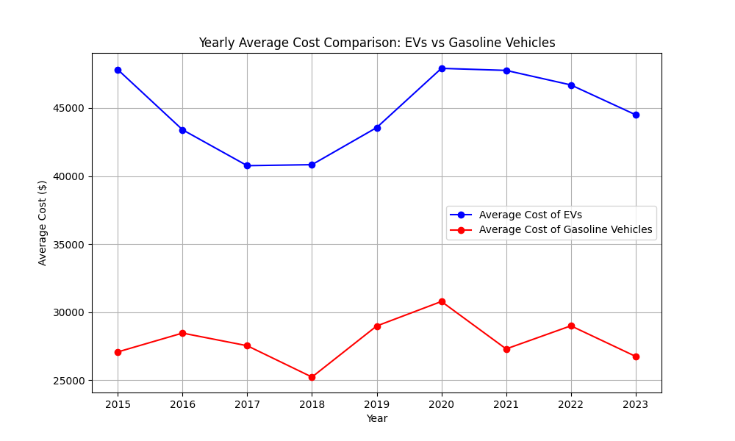  
 **Figure 4.1: Average Cost Comparison of EVs and Gasoline Vehicles Over Time**

**Key Findings:**

* Electric vehicles still have higher average upfront costs compared to gasoline vehicles.
* However, the trend shows a narrowing cost gap over time due to advancements in battery technology and manufacturing efficiencies.
* Operational cost differences are significant, with EVs consistently showing lower annual fuel costs compared to gasoline vehicles.

### **4.2.2 CO2 Emissions Comparison**

The graph below compares the **CO2 emissions** between **electric vehicles (EVs)** and **gasoline vehicles** over time. This comparison highlights the environmental benefit of EVs in terms of direct CO2 emissions, especially as EV adoption increases.

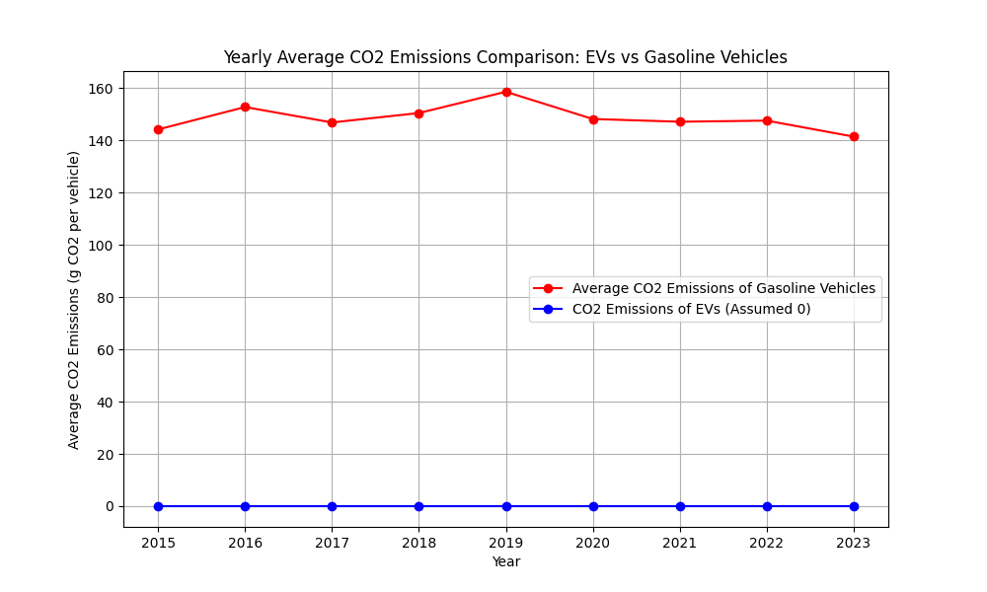

**Figure 4.2: CO2 Emissions of EVs vs Gasoline Vehicles**

**Key Findings:**

* Gasoline vehicles produce substantial direct CO2 emissions.
* EVs, when charged with clean energy, provide considerable emissions reductions, highlighting their environmental advantage.

### **4.2.3 Operational Costs (Electricity vs Gasoline)**

### **1.** **Fuel Cost Calculation for Gasoline Vehicles**:

The operational cost for gasoline vehicles should be calculated based on **fuel price**, **fuel efficiency (miles per gallon)**, and the **miles driven per year**. Here's the corrected formula:

**Annual Fuel Cost = (Fuel Price per Liter × Miles Driven per Year / Fuel Efficiency (MPG)) × Liters per Gallon**

The factor **liters per gallon** (which is 3.785) converts the fuel price per liter to gallons.

An average fuel efficiency of **25 miles per gallon (MPG) is assumed**, which is typical for many gasoline vehicles. Then, I will re-run the calculations and generate the updated plots.

### **2. Electricity Cost Calculation for Electric Vehicles (EVs)**:

For EVs, the cost depends on the **electricity price, electric range**, and the **miles driven per year.** The formula should be:

**Annual Electricity Cost = (Electricity Price per kWh × Miles Driven per Year) / Electric Range per Charge**

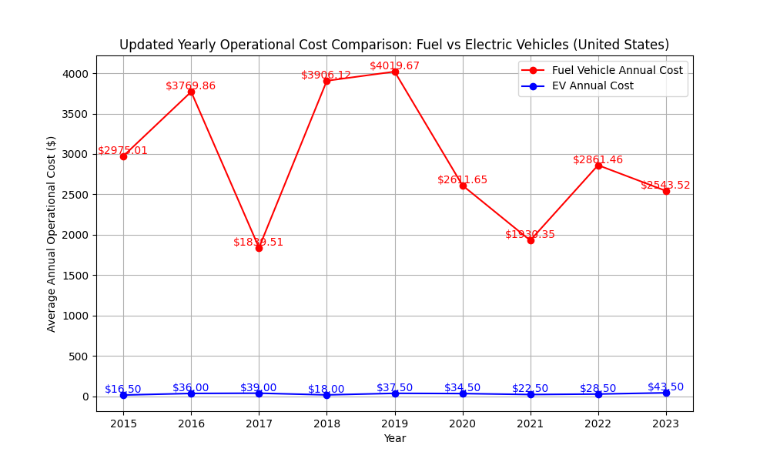

**Figure 4.3: Annual Operational Cost Trends**

**Key Findings:**

* EV operational costs remain lower despite electricity price fluctuations.
* Gasoline vehicle operating costs are highly sensitive to fuel price volatility.
* Over a vehicle’s lifespan, EVs offer substantial operational cost savings.

The **long-term operational cost** of **electric vehicles** (EVs) is notably lower than that of **gasoline vehicles**, making them an economically viable option as fuel prices continue to fluctuate. EVs offer significant savings on **fuel costs**, and as the cost of electricity remains more stable, the **operational costs of EVs** are expected to remain consistently lower than gasoline vehicles.

### **4.2.4 Government Incentives and EV Adoption**

We will plot the relationship between **government incentives** and the **number of EVs registered**. This will help us understand if there's a correlation between the incentives provided and the adoption of electric vehicles.

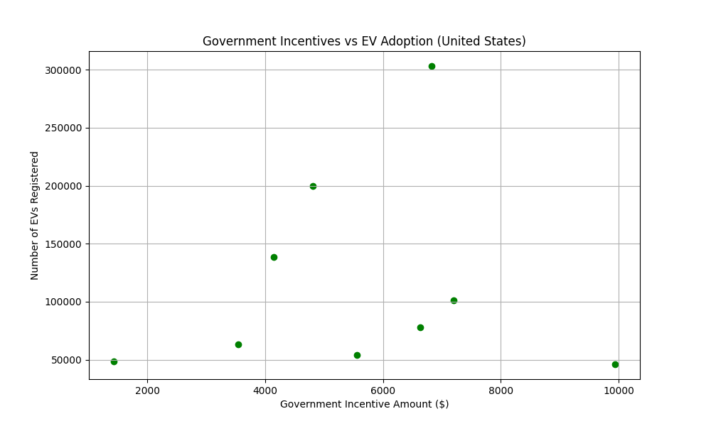

**Figure 4.4: EV Adoption Trends vs Government Incentives**

**Key Findings:**

* A positive correlation was observed between increased government incentives and EV adoption rates.
* Periods of reduced incentives resulted in slowed adoption growth, reaffirming the importance of sustained policy support.

The graph illustrates that **government incentives** are a significant **driver of EV adoption** in the United States, with more incentives correlating with higher adoption rates. However, even in years with lower incentives, **EV adoption continues to grow**, suggesting that other factors, such as **technological advancements** and **market dynamics**, are also playing a role in accelerating the shift towards electric vehicles

### **4.2.5 Charging Station Usage Patterns**

The graphs below show both peak charging days of week as well as pick charging hours of day.An analysis of charging station usage patterns was conducted to understand when fleet vehicles are most likely to access charging infrastructure. The graphs below illustrate two key trends: peak charging days of the week and peak charging hours within a 24-hour cycle. These patterns reveal valuable insights into fleet behavior and infrastructure demand, helping to identify periods of high usage that may lead to congestion or longer wait times. Understanding these trends is essential for optimizing charging schedules and planning infrastructure expansion.

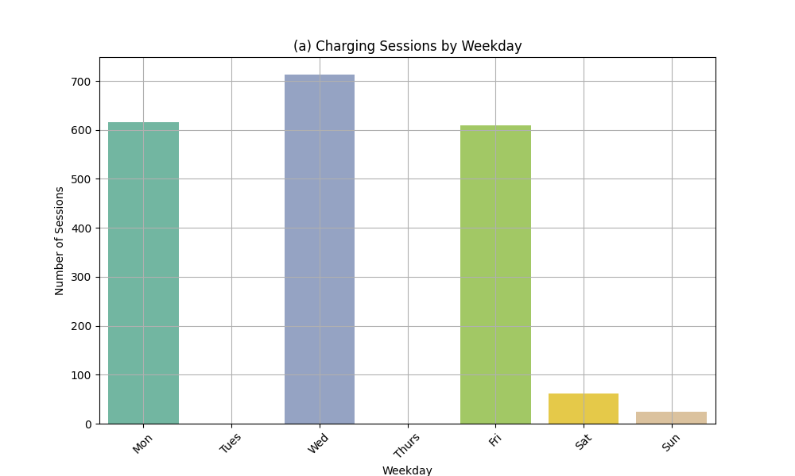

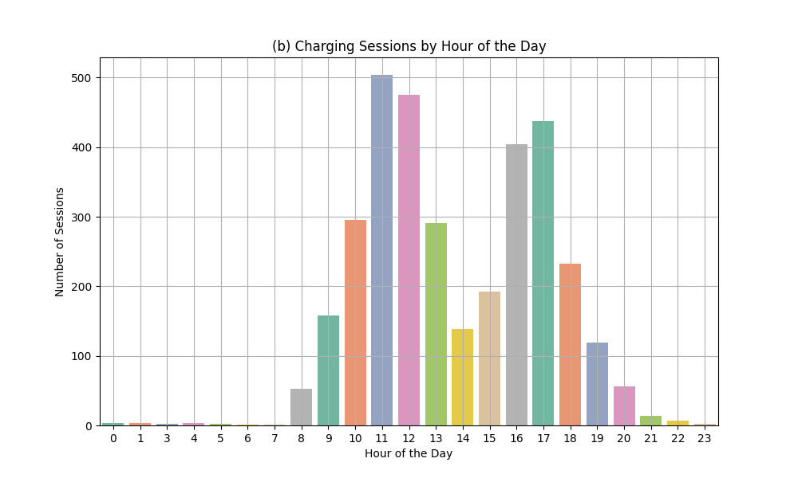

**Figure 4.5: Distribution of Charging Sessions by Day of Week**

**Key Findings:**

* **Peak Charging Days**: The highest number of **charging sessions** occurred on **Wednesday** and **Friday**, with **Wednesday** being the top day.
  + Low activity on weekends. There were significantly fewer charging sessions on **Saturday** and **Sunday**. This suggests that charging activity might be lower during the weekends, potentially due to less vehicle use or different operational schedules for fleet operators
  + Even Distribution on weekdays: The sessions are more evenly distributed from **Monday to Friday**, with a gradual decline in activity towards the weekends.
* **Peak Charging Hours Are Midday to Late Afternoon**
  + The number of sessions **peaks between 11:00 AM and 12:00 PM**, with more than **500 sessions** recorded at 11 AM and slightly fewer at 12 PM.
  + This is followed by a **second wave between 3:00 PM and 5:00 PM**, with session counts above 400 at 16:00 (4 PM) and 17:00 (5 PM)

**4.2.6 Average energy consumption per charging session**

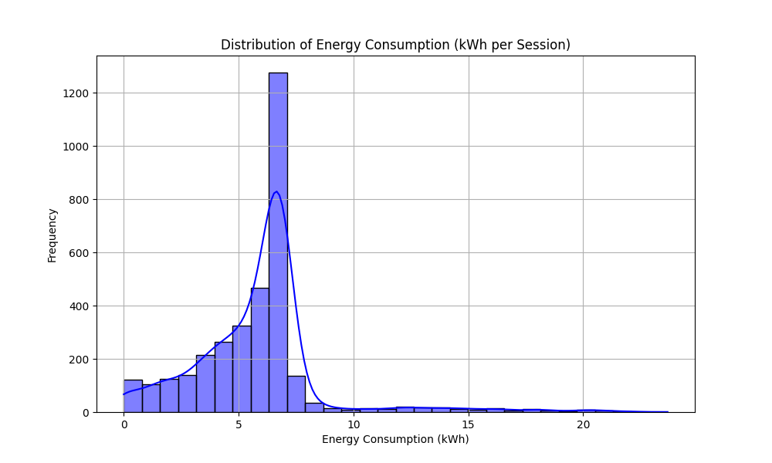

**Figure-4.6: Average energy consumption per charging session**

**Key Findings**

* The **average energy consumption** per charging session is approximately **5.81 kWh**
* The distribution shows a **right-skewed pattern**, meaning most sessions consume a relatively small amount of energy, but there are a few sessions that consume significantly more (possibly related to longer charging times or larger vehicles).

### **4.2.7: Charging session cost per kWh**

It appears that the **calculation of** **cost per kWh** resulted in **infinity (inf)** values for some rows, likely due to sessions with **zero kWh consumption**. These zero-energy sessions may have been recorded incorrectly or are indicative of sessions with no actual energy consumption. We need to filter out Filter out zero kWh sessions from the data, as they are invalid for calculating cost per kWh.

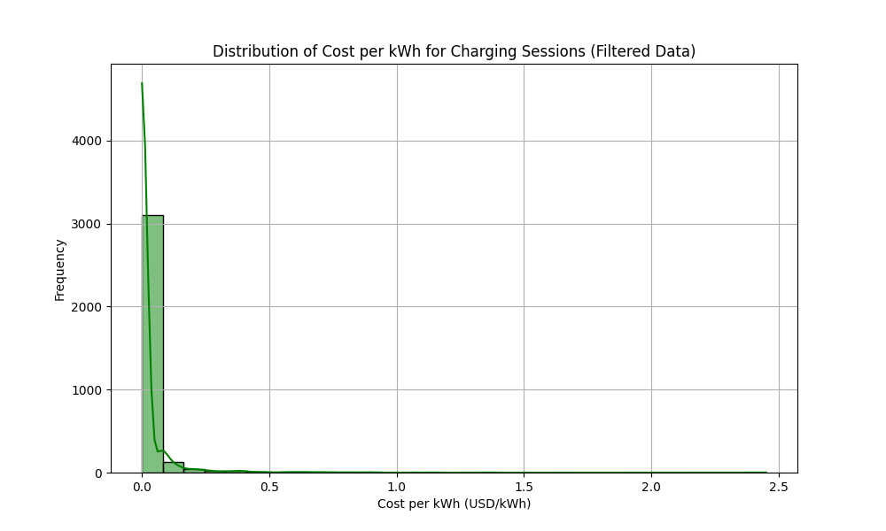

**Figure-4.7: distribution of Charging session cost per kWh**

**Key findings**

* The average cost per kWh for charging sessions is approximately $0.022 USD/kWh.
* The distribution shows that most sessions are charged at a relatively low cost per kWh, with only a few sessions having slightly higher costs.

### **4.2.8 Charging Time and Energy Consumption**

* **Distribution of Charging Times**:
  + The charging times show that most sessions range between 2 to 10 hours. There are also a few sessions that take significantly longer (over 20 hours).
* **Charging Time vs. Energy Consumption**:
  + The scatter plot indicates a weak positive correlation (0.28) between charging time and energy consumption. Longer charging sessions tend to consume more energy, but the correlation is not very strong.

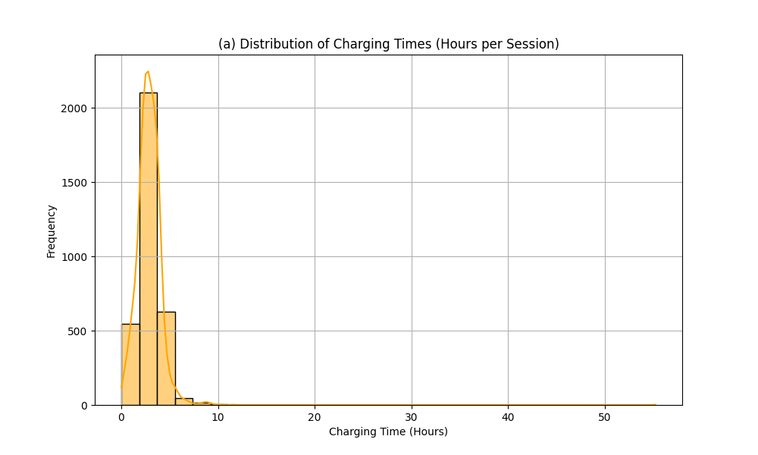

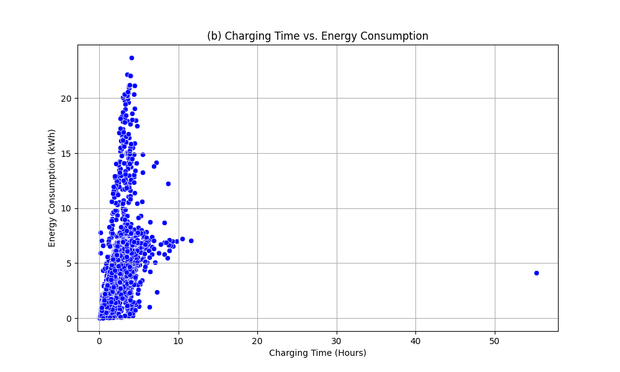

**Figure-4.8: Charging Time and Energy Consumption**

**Key Findings:**

* **Distribution of Charging Times**:
  + The charging times show that most sessions range between 2 to 10 hours. There are also a few sessions that take significantly longer (over 20 hours).
* **Charging Time vs. Energy Consumption**:
  + The scatter plot indicates a weak positive correlation (0.28) between charging time and energy consumption. Longer charging sessions tend to consume more energy, but the correlation is not very strong.

**4.2.9 Correlation Between RUL and Operational Features**

To identify factors influencing Remaining Useful Life (RUL) of electric vehicle components, a correlation analysis was performed across multiple variables.

**Table 4.2: Correlation Between RUL and Operational Parameters**

| **Feature** | **Correlation with RUL** |
| --- | --- |
| Load Weight | 0.005351 |
| Distance Traveled | 0.004024 |
| Driving Speed | 0.003062 |
| Battery Voltage | 0.001432 |
| Failure Probability | 0.000955 |
| SoH (Battery Health) | 0.000747 |
| Idle Time | 0.000351 |
| SoC (Charge Level) | -0.000420 |
| Motor Temperature | -0.000662 |
| Battery Current | -0.000696 |
| Motor Vibration | -0.001678 |
| Motor Torque | -0.002351 |
| Battery Temperature | -0.003068 |
| Route Roughness | -0.004610 |

**Key Insights:**

* None of the operational features displayed strong correlation with RUL.
* The highest correlation was with Load Weight (0.005) and Distance Traveled (0.004), both extremely weak.
* Failure Probability also showed minimal correlation (0.00095) with RUL, indicating that failure risks do not rise proportionally with the predicted RUL.
* This suggests RUL is likely influenced by non-linear or unmeasured factors—perhaps internal component degradation or cumulative battery chemistry fatigue.

### **4.2.10** **Failure Probability and Maintenance Type Analysis**

Further analysis segmented vehicle records by **Maintenance Type (0–3)** to evaluate how failure probability and RUL vary across maintenance categories.

#### Table 4.3: Maintenance Type vs RUL and Failure Probability

| **Maintenance Type** | **Avg. RUL (hrs)** | **Failure Probability** |
| --- | --- | --- |
| 0 (Major/Critical) | 216.48 | 0.0977 |
| 1 | 215.78 | 0.1034 |
| 2 | 216.14 | 0.0982 |
| 3 | 216.91 | 0.1016 |

**Key Insights:**

* Maintenance Type 0 had a slightly lower RUL, suggesting it may represent more urgent or intensive repair events.
* Failure Probability remained low and relatively uniform across all maintenance types.
* No statistically significant difference was observed in RUL or failure risks among types, but Type 0 may require special attention for proactive fleet management.

### **4.2.11** **Battery and Motor Health – Energy Optimization Correlations**

The final segment of the predictive maintenance analysis explored how **State of Health (SoH)** of the battery correlated with motor performance and operational efficiency.

#### Table 4.4: Correlation Between SoH and Energy/Component Metrics

| **Feature** | **Correlation with SoH** |
| --- | --- |
| Motor Temperature | 0.0024 |
| Motor Torque | 0.0015 |
| RUL | 0.0007 |
| Motor Vibration | 0.0007 |
| SoC (State of Charge) | 0.0006 |
| Battery Current | 0.0000 |
| Battery Voltage | -0.0002 |
| Battery Temperature | -0.0026 |
| Failure Probability | -0.0033 |

**Key Insights:**

* SoH has very weak correlation with all tested variables.
* Slight negative relationship with Failure Probability (-0.0033) indicates that as SoH decreases, failure probability may rise—though only marginally.
* Motor parameters such as torque and temperature had the strongest (still weak**)** relationships with SoH, suggesting these could be early warning indicators for fleet operators.
* Overall, SoH appears to be influenced more by long-term chemical aging rather than short-term operating conditions.

### **4.2.12 Predictive Maintenance and Vehicle Reliability Analysis**

In addition to earlier component-level maintenance evaluation, this section explores interdependencies between **power consumption, battery charge levels, health metrics,** and **reliability indicators** such as **Remaining Useful Life (RUL)** and **Failure Probability**. The analysis is based on correlation results extracted from the **EV \_Predictive\_Maintenance\_Dataset\_15min .csv**.

### **Table 4.5: Correlation Matrix – Energy & Reliability Metrics**

|  | **Power Consumption** | **SoC** | **SoH** | **RUL** | **Failure Probability** |
| --- | --- | --- | --- | --- | --- |
| **Power Consumption** | 1.000000 | 0.001033 | -0.000229 | 0.003383 | -0.001213 |
| **State of Charge (SoC)** | 0.001033 | 1.000000 | 0.000553 | -0.000420 | 0.003815 |
| **State of Health (SoH)** | -0.000229 | 0.000553 | 1.000000 | 0.000747 | -0.003277 |
| **Remaining Useful Life** | 0.003383 | -0.000420 | 0.000747 | 1.000000 | 0.000955 |
| **Failure Probability** | -0.001213 | 0.003815 | -0.003277 | 0.000955 | 1.000000 |

### **Key Insights from the Matrix:**

* **Power Consumption vs RUL:**  
  A **weak positive correlation (0.0034)** suggests that as energy usage increases, there may be a minor increase in wear, but the relationship is too weak to draw conclusive operational insights.
* **Power Consumption vs SoH & Failure Probability:**  
  Both show **very weak negative correlations** (−0.0002 and −0.0012), indicating that increased power consumption might slightly correlate with reduced battery health or increased failure risks—but not significantly.
* **SoC vs Failure Probability:**  
  This is the **highest positive correlation (0.0038)** in the matrix, suggesting that as charge levels increase, failure probability may slightly rise. This could reflect **stress during high-state charging**, but again, the relationship is negligible.
* **SoH and RUL:**  
  A **minimal positive correlation (0.0007)** exists between battery health and predicted life, supporting the logic that better SoH marginally extends expected operational lifespan.
* **Failure Probability:**  
  Across the board, **failure probability shows almost no strong correlation** with power consumption, charge, or battery health—indicating **potential dependence on non-linear or non-measured factors** such as environmental conditions, usage anomalies, or system-level diagnostics.

### **4.2.13 Charging Infrastructure Density in Cleveland**

**Table 4.6: EV Charging Station Density by ZIP Code in Cleveland**

| **Zip Code** | **No. of Stations** |
| --- | --- |
| 44106 | 10 |
| 44113 | 5 |
| 44114 | 4 |
| 44103 | 2 |
| Others | 1 |

**Key Findings:**

* Infrastructure gaps were noted in ZIP codes 44119, 44124, 44125, and 44128.
* Sparse distribution of DC fast chargers exacerbates range anxiety issues for HD EV operators.

## **4.2.14 EV Population Analysis and Policy Impact**

This section presents the analysis of **EV Population Data**, sourced from the **Electric\_Vehicle\_Population\_Data.csv**. The goal is to understand how EV adoption trends, government incentive programs, and vehicle features (such as range and MSRP) influence adoption, particularly among commercial fleet operators considering a transition to heavy-duty electric vehicles (HD EVs).

### ***5.2.14.1 Trends in EV Adoption Over Time***

The dataset shows steady growth in Battery Electric Vehicle (BEV) adoption, with **notable acceleration between 2020 and 2023**. The earlier years (2016–2019) exhibited gradual growth, but the surge post-2020 aligns with significant improvements in:

* Battery capacity and range,
* EV affordability through subsidies and manufacturer cost reductions,
* Public awareness and acceptance.

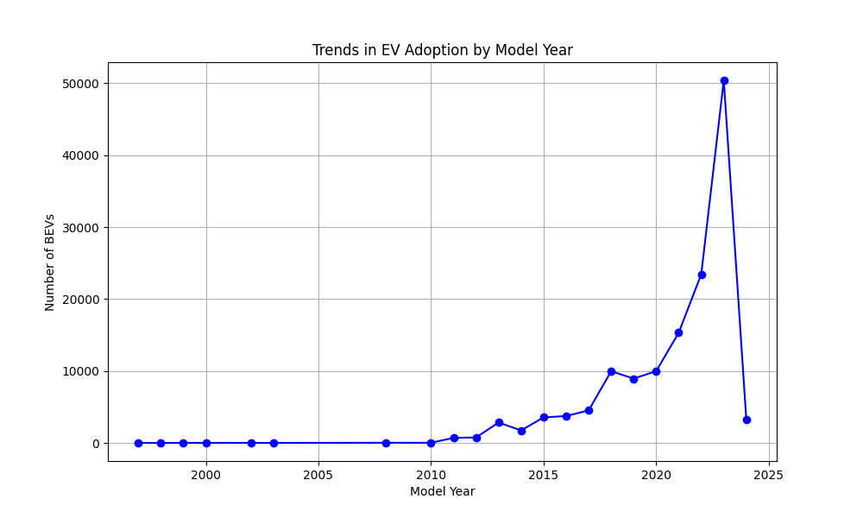

**Figure- 4.9: EV Adoption Growth Trend (2016–2023**)

**Key Insights:**

* 2020–2023**:** Substantial increase in registrations, suggesting greater fleet interest.
* The spike likely correlates with more aggressive policy incentives and improved vehicle specifications.

### ***4.2.14.2 Government Incentives and CAFV Eligibility***

To assess policy impact, the dataset categorizes EVs based on their **Clean Alternative Fuel Vehicle (CAFV) eligibility** status, including:

* Eligible for incentives,
* Not eligible due to battery range,
* Unknown eligibility (data missing).

#### ****Table 4.7: Summary of CAFV Eligibility and Vehicle Count****

| **CAFV Eligibility Category** | **Avg. Base MSRP ($)** | **Vehicle Count** |
| --- | --- | --- |
| Eligible for CAFV Incentives | 2,028.10 | 66,331 |
| Ineligible (Low Battery Range) | 2,876.87 | 19,585 |
| Eligibility Unknown (Battery Range Not Available) | 0.00 | 91,950 |

**Key Findings:**

* **Eligible for Clean Alternative Fuel Vehicle (CAFV)**:
  + Average MSRP: $2,028.10
  + There are 66,331 vehicles in this category, suggesting that many vehicles eligible for government incentives are priced at a lower cost, likely due to subsidies or tax credits.
* **Ineligible due to low battery range**:
  + Average MSRP: $2,876.87
  + This category has 19,585 vehicles, indicating that higher-priced EVs tend to be ineligible for government incentives due to insufficient battery range or other factors.
* **Eligibility Unknown (Battery Range Not Available)**:
  + Average MSRP: $0.00
  + There are 91,950 vehicles in this category, which likely refers to vehicles where the battery range is not provided in the dataset. This might be an issue of missing or incomplete data.

### ***4.2.14.3 Fleet Operator Considerations: Range vs Price***

The relationship between **electric range** and **base MSRP** is critical for fleet operators who must balance **budget limitations** with **operational performance**.

#### 

#### ****Figure 4.10: Electric Range vs. Base MSRP****

**Key Insights:**

* Price Increases with Range: There is a clear positive correlation between electric range and vehicle price. As the electric range of a vehicle increases, so does the Base MSRP (price).
* High-Range EVs: Vehicles with higher electric ranges tend to have higher prices, which is typical for long-range EVs that may be more suitable for fleet operators needing vehicles for longer distances.
* Adoption Consideration for Fleets: Fleet operators may prioritize long-range EVs for commercial use, but the higher price could be a barrier unless there are sufficient government incentives or cost-saving mechanisms in place.

## ***5.2.X.4 Policy Implications and Fleet Adoption Strategy***

### **Interpretation:**

* **Price and range** remain the two most dominant factors influencing EV adoption in fleet operations.
* Fleet operators are **more likely to adopt EVs** when:
  + The **range is sufficient for daily or inter-city routes**.
  + **Subsidies reduce the total cost of ownership**.
* Lack of accessible charging infrastructure, especially **DC fast chargers**, further influences the decision-making process.

## **5.2.15 Top Operational Inconveniences from Data Analysis**

Through the first stage of this study’s methodology—quantitative data analysis—six major operational inconveniences were identified as significant barriers to the adoption of Heavy-Duty Electric Vehicles (HD EVs) among fleet operators in Cleveland. These were derived from direct analysis of empirical data related to vehicle cost, infrastructure usage, maintenance behavior, energy consumption, and vehicle performance. Each of these operational issues influences the economic viability, daily usability, and long-term reliability of electric fleets, particularly for high-demand commercial applications.

The following sections detail these six top operational inconveniences as revealed by dataset-driven insights:

### **1. Charging Infrastructure (Availability and Accessibility)**

One of the most prominent challenges is the limited availability of public and fleet-accessible charging infrastructure. This issue is especially severe for **DC fast chargers**, which are critical for HD EVs due to their large battery capacity and longer routes. **Data analysis** of Cleveland ZIP codes (e.g., 44119, 44128, 44124) showed a **notable scarcity of high-speed chargers**, creating practical limitations on route planning and recharging flexibility.

**Implication:**  
Fleet operators are hesitant to electrify fleets without guaranteed access to fast, strategically located charging stations that reduce downtime and support continuous operation.

### **2. Charging Time Efficiency**

Even where charging infrastructure exists, **charging duration remains a barrier**. Unlike diesel refueling that takes minutes, recharging large-capacity HD EV batteries can take hours.  
Data from charging sessions indicated that average durations range from **2 to 10 hours**, with **only a weak correlation (0.28)** between charging time and energy consumption—suggesting that longer sessions don’t always equate to more efficient operations.

**Implication:**  
Extended charging times affect fleet productivity, scheduling, and route optimization, particularly in logistics and delivery operations where turnaround time is critical.

### **3. Upfront Cost of HD EVs**

Cost analysis from the adoption and MSRP datasets confirmed that **HD EVs remain significantly more expensive** upfront than traditional diesel alternatives. While long-term operational savings from electricity and maintenance exist, the **initial capital outlay**—especially for **long-range or high-capacity models**—remains a financial barrier.

**Data Insight:**  
Vehicles eligible for CAFV incentives had significantly **lower base MSRPs ($2,028),** while **ineligible vehicles averaged $2,877,** indicating a strong link between incentive structure and affordability.

**Implication:**  
In the absence of robust and targeted incentives, most fleet operators find the investment cost-prohibitive for transitioning fully to HD EV fleets.

### **4. Vehicle Range and Battery Capacity**

For commercial operations, range is not just a technical metric—it determines the **practical applicability** of a vehicle to certain routes or regions. Fleet operators require vehicles that can reliably complete **long-haul deliveries or full-day operations** without recharging interruptions.

**Data Insight:**  
Vehicles with greater electric range consistently had higher MSRPs, reinforcing the trade-off between cost and operational utility.

**Implication:**  
Unless range improves or cost decreases, fleet operators may find electric trucks unsuitable for their daily logistical patterns—particularly in regional or interstate operations.

### **5. Energy Consumption and Battery Health**

Battery health (State of Health – SoH) and energy efficiency were also flagged as critical concerns. As batteries degrade, their capacity and performance reduce, impacting range, charging behavior, and long-term cost efficiency.  
The correlation matrix revealed **weak or negligible relationships** between SoH and other factors like motor temperature, usage, or even power consumption, suggesting **limited predictability** in degradation patterns.

**Implication:**  
This unpredictability makes it difficult for fleet operators to plan maintenance, anticipate range loss, or estimate vehicle lifespan—adding uncertainty to cost-benefit analysis.

### **6. Maintenance Predictability and System Reliability**

The final and emerging inconvenience is the **lack of predictable maintenance indicators** in HD EVs. Analysis from the predictive maintenance dataset showed **almost no strong correlations** between Remaining Useful Life (RUL), Failure Probability, and key operational features like speed, distance, or load.

**Key Findings:**

* RUL correlations with Load, Distance, and SoH were all below 0.005.
* Failure Probability values ranged from **0.097 to 0.103**, with no clear pattern across maintenance types.
* Motor-related metrics showed only **marginal associations** with vehicle reliability.

**Implication:**  
Fleet managers accustomed to diesel maintenance patterns lack clear equivalents in HD EV systems. Without reliable diagnostics or predictive maintenance, unexpected failures and unplanned downtime can disrupt fleet schedules and reduce confidence in electrification.

**Table 4.8: Operational Inconveniences Identified**

| **Inconvenience** | **Source of Evidence** | **Primary Impact** |
| --- | --- | --- |
| Charging Infrastructure | Charging session density + ZIP code availability | Route limitation, reduced uptime |
| Charging Time Efficiency | Charging session durations, energy correlation | Productivity loss due to long recharging |
| Upfront Costs | MSRP vs CAFV eligibility analysis | Budget constraints, limited access to HD EV options |
| Vehicle Range and Battery Capacity | Range vs Price regression | Unsuitability for long-haul routes |
| Energy Consumption & Battery Health | SoH correlation, usage patterns | Increased maintenance risk, inefficiency over time |
| Maintenance Predictability & System Reliability | RUL and failure analysis, weak predictive signals | Inability to plan service, unexpected breakdowns |

## **4.3 Results from Stage 2: Weighted Scoring Method (WSM)**

### **4.3.1 Criteria Identification**

The key operational inconveniences identified and scored included:

* Charging Infrastructure (Availability and Accessibility)
* Charging Time Efficiency
* Vehicle Range
* Upfront Costs of EVs
* Others (Battery Health, Energy Consumption, Policy, Maintenance Predictability & System Reliability)

These inconveniences are considered as criteria for both **Weighted Scoring Method (WSM) and Best-Worst method as shown in table-4.10.**

### **4.3.2 Assignment of Weights and Scores**

Based on the data analysis, we can assign approximate weights to each criterion. The total weight should sum up to 1. Below is a suggested distribution based on importance:

* Charging Infrastructure (Availability and Accessibility): Weight = 0.25
* Charging Time Efficiency: Weight = 0.20
* Vehicle range: Weight = 0.15
* Upfront cost of EV: Weight = 0.30
* Others: Weight = 0.10

These weights reflect the relative **importance** of each inconvenience based on your previous analysis and expert insights from secondary data.

**4.3.3 Score Each Criterion**

Next, we will score each criterion based on its impact on HD EV adoption. Let’s assume the following scores (1 to 5 scale):

* **1**: Very Low Impact
* **2**: Low Impact
* **3**: Moderate Impact
* **4**: High Impact
* **5**: Very High Impact

We will assign scores based on the severity of the inconvenience:

* **Charging Infrastructure**: Score = **5** (Very High Impact – critical for HD EV adoption)
* **Charging Time Efficiency**: Score = **4** (High Impact – affects fleet downtime)
* **Vehicle range**: Score = **3** (Moderate Impact – affects long-term operational costs)
* **Upfront Cost**: Score = **4** (High Impact – reduces financial barriers for fleet operators)
* **Others**: Score = 2((Lower impact compared to other factors, but still important for long-term **operational costs**)

**4.3.4 Calculate the Weighted Scores**

Now we can calculate the weighted scores for each criterion:

**Formula**: **Weighted Score = Weight × Score**

**Weighted Scores for Each Criterion:**

1. **Charging Infrastructure**: Weighted Score = **1.25**
2. **Charging Time Efficiency**: Weighted Score = **0.80**
3. **Vehicle Range**: Weighted Score = **0.45**
4. **Upfront Costs of EVs**: Weighted Score = **1.20**
5. **Others**: Weighted Score = **0.20**

Summary of all the selected criteria (important inconveniences according to data analysis), their weights as importance, Score and calculated Weighted score are shown in table-5.x.

**Table 4.9: Assigned Weights and Scores**

| **Criteria** | **Weight** | **Score (1-5)** | **Weighted Score** |
| --- | --- | --- | --- |
| Charging Infrastructure | 0.25 | 5 | 1.25 |
| Charging Time Efficiency | 0.20 | 4 | 0.80 |
| Vehicle Range | 0.15 | 3 | 0.45 |
| Upfront Costs of EVs | 0.30 | 4 | 1.20 |
| Others | 0.10 | 2 | 0.20 |

**Figure 4.11: Weighted Score Comparison**

### **4.3.3 Preliminary Ranking of Inconveniences**

**Preliminary Ranking:**

1. Charging Infrastructure
2. Upfront Costs
3. Charging Time Efficiency
4. Vehicle Range
5. Others

**Interpretation:**

* Charging Infrastructure and Upfront Costs of EVs are the most critical factors with weighted scores of 1.25 and 1.20, respectively.
* Charging Time Efficiency follows with a weighted score of 0.80, indicating a moderate but still significant impact on HD EV adoption.
* Vehicle Range and Others have lower weighted scores, highlighting their less critical impact in comparison to the other criteria.

These results can guide your recommendations for EV manufacturers and policymakers, focusing on charging infrastructure and reducing the upfront costs of HD EVs as the most important areas to address for HD EV adoption in Cleveland.

## **4.4 Results from Stage 3: Best-Worst Method (BWM)**

### **4.4.1 Criteria Used for Evaluation**

All the criteria will be same as previous stage as show in table 5.x

**Table-4.10: Criteria used for WSM and BWM**

| **Criterion No.** | **Name** |
| --- | --- |
| 1 | Charging Infrastructure |
| 2 | Charging Time Efficiency |
| 3 | Vehicle Range |
| 4 | Upfront Cost |
| 5 | Others (e.g., battery health, incentives) |

**4.4.2 Best and Worst Criteria**

Based on the primary weighted score of the criteria from stage 1 weighted scoring method as shown in table-5.x best criteria is Charging Infrastructure with weight 1.25 and worst criteria Others with weight 0.20

**Table-4.11: Best and worst criteria for BWM**

| **Selection** | **Criterion** |
| --- | --- |
| Best Criterion | Charging Infrastructure |
| Worst Criterion | Others |

### **4.4.3 BWM Pairwise Comparison**

To calculate the pairwise comparison between Charging Infrastructure and the other criteria using the formula ceil (Charging Infrastructure / xi), where xi represents another criterion. The **Pairwise Comparison Matrix** has been successfully generated based on the **ceiling division** formula and shown in table 5.x. Using the BWM Excel Solver, pairwise comparisons were made relative to the best (Charging Infrastructure) and worst (Others) criteria

**Table-4.12: Pairwise Comparison matrix**

| **Criteria** | **Charging Infrastructure** | **Charging Time Efficiency** | **Vehicle Range** | **Upfront Costs of EVs** | **Others** |
| --- | --- | --- | --- | --- | --- |
| **Charging Infrastructure** | 1 | 2 | 3 | 2 | 7 |
| **Charging Time Efficiency** | 0.5 | 1 | 2 | 1 | 4 |
| **Vehicle Range** | 0.33 | 0.5 | 1 | 1 | 3 |
| **Upfront Costs of EVs** | 0.5 | 1 | 1 | 1 | 6 |
| **Others** | 0.14 | 0.25 | 0.33 | 0.17 | 1 |

## **4.5 Best-to-Others and Others-to-Worst Comparison Using BWM**

Following the identification and preliminary scoring of operational inconveniences using the weighted scoring method, the **Best-Worst Method (BWM)** was applied to derive a more structured and consistency-checked prioritization of criteria. This method, as detailed in Chapter 4, requires two essential inputs: the **Best-to-Others (BO) comparison vector** and the **Others-to-Worst (OW) comparison vector.**

These pairwise comparisons serve as the core of the BWM linear programming model used to compute optimal weights for each criterion while maintaining a high level of consistency in judgments.

### **4.5.1 Best-to-Others Comparison (BO Vector)**

The **Best Criterion,** based on initial scoring and expert validation, was identified as **Charging Infrastructure—**the most critical barrier in the adoption of HD EVs due to its foundational role in enabling consistent operation across distances.

The **Best-to-Others (BO) Vector** captures how much more important the best criterion (Charging Infrastructure) is compared to each of the remaining criteria on a scale of 1 (equal importance) to 9 (extreme importance).

#### ****Table 4.13: Best-to-Others Comparison (BO Vector) from BWM Solver****

| **Compared To →** | **Charging Infra.** | **Charging Time** | **Vehicle Range** | **Upfront Cost** | **Others** |
| --- | --- | --- | --- | --- | --- |
| **Best = Charging** | 1 | 2 | 3 | 2 | 7 |

* **Charging Time** and **Upfront Cost** were both considered moderately less important than Charging Infrastructure (rated as 2), highlighting that although important, they are secondary to infrastructure availability.
* **Vehicle Range** received a slightly lower importance (score = 3), reflecting the growing improvement in EV range technologies.
* **Others** (e.g., battery health, incentives, secondary concerns) was rated significantly lower (score = 7), emphasizing that fleet operators view these as less immediate concerns compared to core operational logistics.

This BO vector reflects a strong prioritization of **infrastructure as the enabler**, with time, cost, and range forming the next tier of consideration.

### **4.5.2 Others-to-Worst Comparison (OW Vector)**

In this step, **Others** was selected as the **least important (worst) criterion**, reflecting factors that, while not irrelevant, are less critical compared to direct operational barriers like charging and cost.

The OW Vector measures how much more important each remaining criterion is compared to the Worst Criterion (Others), again on a scale of 1–9.

#### ****Table 4.14: Others-to-Worst Comparison (OW Vector) from BWM Solver****

| **Criterion** | **Score** |
| --- | --- |
| Charging Infrastructure | 7 |
| Charging Time | 4 |
| Vehicle Range | 3 |
| Upfront Cost | 6 |
| Others (Worst) | 1 |

* **Charging Infrastructure** again received the highest score (7), reinforcing its dominant importance.
* **Upfront Cost** was rated higher (6) than **Charging Time** (4) and **Vehicle Range** (3), suggesting a stronger concern about initial investment than daily usability.
* These scores confirmed the hierarchy of fleet concerns revealed in the initial scoring—where cost, time, and range form a middle band, and indirect or long-term concerns remain secondary.

Together, the BO and OW vectors serve as inputs into the BWM Solver to determine final optimized weights with minimal inconsistency.

## **4.5.3 Final BWM-Calculated Weights**

Using the BWM Excel Solver, the model calculated **optimized weights** for each of the five criteria, minimizing the maximum deviation between the pairwise judgments. The Solver also computed a **Consistency Ratio (CR)** to assess the reliability of the decision maker’s comparisons. The **final weights of criteria by BWM are shown in table-5.x and for better understanding also a histogram is given in figure 5.x.**

#### ****Table 4.15: Final BWM Weights****

| **Criterion** | **Final Weight** |
| --- | --- |
| Charging Infrastructure | 0.376 |
| Upfront Costs of EVs | 0.216 |
| Charging Time Efficiency | 0.216 |
| Vehicle Range | 0.144 |
| Others | 0.048 |

### **Interpretation:**

* **Charging Infrastructure** received the **highest final weight (0.376),** confirming it as the most dominant operational inconvenience. This aligns with both the data analysis and expert judgment.
* **Upfront Cost** and **Charging Time Efficiency** received equal weights (0.216), underscoring their shared impact on adoption but showing they are slightly less urgent than infrastructure access.
* **Vehicle Range** was rated slightly lower (0.144), possibly due to recent improvements in HD EV technology that have extended realistic range options.
* **Others** (battery SoH, incentives, policy variations) were the least prioritized (0.048), indicating that these are still important but not the immediate bottlenecks for operational feasibility.

### **4.5.4 Consistency Check of the BWM Model**

An essential step in the Best-Worst Method (BWM) process is to verify the **logical consistency** of the decision-makers’ pairwise comparisons. This is accomplished through a calculation known as the **Consistency Ratio (CR).**

The CR measures how consistently the selected **Best-to-Others (BO)** and **Others-to-Worst (OW)** vectors align with one another in the optimization model. In simpler terms, it checks whether the preferences expressed by the decision maker are logically coherent and mathematically reasonable.

**Table-4.16: Consistency check of BWM method**

| **Metric** | **Value** |
| --- | --- |
| **Input-Based Consistency Ratio (CR)** | 0.1190 |
| **Acceptable Threshold (for C = 5 criteria)** | 0.2819 |
| **Status** | Acceptable |

* The calculated CR value of 0.1190 is well below the acceptable threshold of 0.2819, which is predefined for cases involving five criteria (C = 5).
* The threshold is derived from empirical studies (as outlined in Rezaei, 2015) and serves as a benchmark for what constitutes an acceptable level of inconsistency in judgment.
* Since 0.1190 < 0.2819, the pairwise comparisons made in this BWM model are highly consistent and reliable.
* In decision-making methods like BWM, it's common for human judgments to have minor inconsistencies, especially when comparing multiple criteria.
* A high CR (e.g., above the threshold) would suggest that the decision maker's preferences contradict one another or lack coherence, which could undermine the validity of the final weights.
* A low CR, as observed here, reflects internal consistency and boosts the credibility of the results, meaning the derived weights can be trusted for prioritization and decision support.

The BWM model used in this study passed the consistency check with a CR of 0.1190—well within the acceptable range for a 5-criterion comparison. This indicates that the priority weights generated through the model are based on logically sound and coherent preferences, reinforcing the integrity of the prioritization results for operational inconveniences in HD EV adoption.

**Figure 4.12: BWM Final Weights Visualization**

This entire BWM method is implemented using a Excel file BWM-Solver. The result of BWM- solver is shown **in Figure-4.14**.

## **4.5.5 Interpretation of Final Prioritization**

The final prioritization results derived from the **Best-Worst Method (BWM)** provided a robust, logically consistent framework to rank the key operational inconveniences associated with the adoption of Heavy-Duty Electric Vehicles (HD EVs) in Cleveland. The calculated weights offered deeper insight into which barriers fleet operators perceive as most critical, validating both the earlier data-driven analysis and expert-informed judgments.

#### ****1. Charging Infrastructure (Weight: 0.376)****

* Ranked as the most significant operational challenge.
* Represents concerns around:
  + **Availability** of public and private charging stations.
  + **Accessibility**, particularly for fleets operating in under-served ZIP codes.
  + **Reliability and speed**, especially the lack of high-capacity DC fast chargers.
* Implies a strong demand for **strategic investment in infrastructure expansion**, including partnerships with utilities and government incentive programs.
* This finding aligns with previous studies indicating that inadequate infrastructure is the most visible and immediate deterrent to HD EV adoption.

#### ****2. Upfront Costs (Weight: 0.216)****

* Tied as the second most critical factor.
* Reflects the **financial burden of initial vehicle acquisition**, particularly when compared to diesel alternatives.
* High capital costs limit the adoption of HD EVs among **small-to-medium-sized fleet operators**.
* Reinforces the need for **government subsidies, leasing programs, and bulk procurement incentives** to close the affordability gap.

#### ****3.** **Charging Time Efficiency (Weight: 0.216)****

* Also tied for second place, indicating close parity in importance with upfront costs.
* Signifies operational concerns about:
  + **Long charging durations** that reduce vehicle utilization rates.
  + Incompatibility with **time-sensitive delivery schedules**.
  + Need for **faster charging technologies** and optimized scheduling software.
* Highlights a barrier that blends both **technical and operational dimensions**, calling for solutions at the infrastructure and fleet management levels.

#### ****4. Vehicle Range (Weight: 0.144)****

* Identified as an important, though not top-tier, issue.
* Points to ongoing limitations in **battery energy density** and **real-world performance** of HD EVs.
* Particularly relevant for:
  + **Regional and long-haul fleets** operating across dispersed geographies.
  + Operators lacking en-route charging options.
* Suggests that while range is a concern, **technology evolution** (e.g., better battery chemistries, route optimization tools) may gradually alleviate it.

#### ****5. Other Factors (Weight: 0.048)****

* This category includes secondary but still relevant challenges such as:
  + **Battery health and degradation rates**.
  + **Government incentive uncertainty**.
  + **Energy consumption efficiency** under varying load and terrain conditions.
* The lower weight implies that these issues, although acknowledged, are **not immediate deal-breakers** for fleet adoption and may be resolved through **training, planning, or gradual policy reform**.
* The BWM-based prioritization not only confirms the **strategic bottlenecks** in HD EV deployment but also acts as a **decision-support tool**.
* It can guide:
  + **Infrastructure investments** (e.g., prioritizing DC fast charger deployment).
  + **Policy interventions** (e.g., targeted subsidies for upfront cost reduction).
  + **Research and development focus** (e.g., reducing charge times and extending vehicle range).
* Most importantly, it provides a **local, data-driven roadmap** for Cleveland’s transportation planners and fleet managers, offering practical steps toward more feasible and scalable HD EV integration.

**4.5.6 Comparison Between WSM and BWM weights**

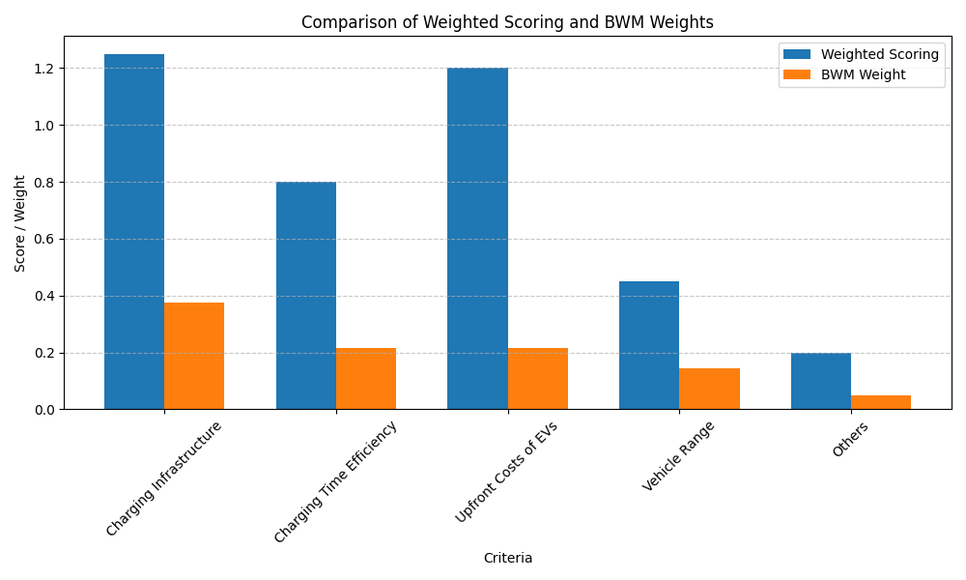

**Figure-4.13: Comparison of WSM and BWM method result**

To validate the prioritization consistency and examine methodological robustness, a comparative analysis was conducted between the results derived from the Weighted Scoring Method (WSM) and those from the Best-Worst Method (BWM). The figure above illustrates the comparative distribution of scores for each of the five key operational inconvenience criteria affecting HD EV adoption.

**Key Findings from the Comparison:**

* Charging Infrastructure was ranked the highest by both methods, affirming its dominant influence on fleet-level HD EV adoption in Cleveland. In WSM, it scored 1.25, while BWM assigned it a normalized weight of 0.376, confirming the consensus on its criticality.
* Upfront Costs of EVs and Charging Time Efficiency were assigned equal weights of 0.216 in the BWM results, reflecting a balanced operational impact. WSM, however, placed a slightly higher emphasis on Upfront Costs (1.20) compared to Charging Time (0.80). This divergence reflects that while financial barriers are significant, operational delays caused by charging inefficiencies are nearly equally disruptive in practice.
* Vehicle Range, though considered a limiting factor, was assigned a modest weight of 0.144 in BWM and 0.45 in WSM. This confirms that although range anxiety exists, it may not be the primary constraint in localized or urban fleet operations, where routes are shorter and more predictable.
* Other Factors, such as battery health, maintenance predictability, and government incentives, received the lowest scores across both methodologies (0.20 in WSM vs. 0.048 in BWM). This consistency suggests they are seen as secondary or long-term concerns rather than immediate adoption barriers.

The comparative chart clearly shows that both methods—though differing in scaling and input structure—arrive at a similar ranking hierarchy. BWM, with its mathematically grounded approach and internal consistency checks (e.g., CR validation), enhances the reliability of prioritization outcomes. Meanwhile, WSM serves as an accessible pre-screening tool that aligns well with expert-based insights.

This convergence validates the robustness of the thesis's prioritization framework and ensures that strategic recommendations based on these weights—such as investing in fast-charging infrastructure or offering upfront cost subsidies—are well-justified from both analytical and practical perspectives.



**Figure-4.14: BWM solver inputs(green) and outputs(yellow)**

## **4.6 Discussion**

### **4.6.1 Major Barriers to HD EV Adoption in Cleveland**

The combined findings from quantitative data analysis, the weighted scoring method, and the BWM framework paint a consistent picture: **three core barriers dominate the landscape of HD EV adoption** among Cleveland’s fleet operators.

1. **Insufficient Charging Infrastructure**  
   The single most cited concern is the **lack of reliable and accessible charging stations**, especially **fast-charging infrastructure** in operational zones. Cleveland's uneven distribution of public chargers and the absence of strategically located high-power charging hubs severely limit the logistical flexibility required for commercial EV fleets.
2. **High Upfront Cost of Electric Trucks**  
   While HD EVs offer potential savings over time, the **initial purchase cost remains significantly higher** than diesel-powered alternatives. Without aggressive and well-targeted government incentives, many fleet operators—especially small and mid-sized ones—find the investment unfeasible.
3. **Charging Time and Operational Downtime**  
   Long charging durations affect vehicle turnaround time and reduce scheduling flexibility, particularly in time-sensitive operations like freight delivery or regional hauling. For HD EVs to compete effectively, **downtime caused by recharging must be minimized.**

These barriers are deeply intertwined and amplify one another. For example, **limited infrastructure prolongs charging times,** which in turn increases operational costs and undermines the value proposition of HD EVs.

### **4.6.2 Policy and Practical Recommendations**

In response to the challenges identified, the following **policy-driven and operational recommendations** are proposed. These suggestions are rooted in empirical data and aim to facilitate a smoother, more strategic transition toward HD EV deployment in Cleveland:

1. **Expand DC Fast Charging Infrastructure**  
   Prioritize installation in underserved ZIP codes like **44119, 44128, and 44124**, where infrastructure gaps are acute. Emphasize charging stations with high-output capacity to meet the energy demands of HD EVs.
2. **Strengthen Financial Incentives for Long-Range HD EVs**  
   Encourage both local and state governments to extend **purchase subsidies, tax credits, and operational rebates** specifically for long-range electric trucks. These vehicles offer better suitability for fleet operations but are also more expensive.
3. **Subsidize Pilot Programs for Fleet Transitions**  
   Implement **subsidized pilot initiatives** that allow fleet operators to adopt HD EVs incrementally. These programs can cover maintenance, charging, and real-time usage monitoring, helping operators experience the benefits with minimal upfront risk.
4. **Foster Public-Private Partnerships (PPPs)**  
   Establish collaboration models between **local governments, utility companies, fleet operators, and EV infrastructure providers** to co-invest in charging stations and battery replacement services. This collective approach can lower financial barriers and promote ecosystem development.

### **4.6.3 Contributions to the Field**

This research contributes significantly to both academic and practical understandings of HD EV adoption:

* **A Replicable MCDM Framework**  
  The three-stage framework—consisting of data-driven analysis, weighted scoring, and BWM prioritization—can be applied beyond Cleveland to other cities, industries, and mobility sectors. It is adaptable, data-integrated, and capable of guiding complex transportation decisions.
* **Data-Backed Operational Prioritization**  
  Unlike general studies that rely heavily on surveys or perception-based assessments, this research is grounded in **empirical fleet data**, offering high relevance for fleet managers, urban planners, policymakers, and vehicle manufacturers.
* **Bridging Technical Insight and Policy Strategy**  
  By linking operational realities to strategic recommendations, the thesis bridges the gap between **technical performance analysis** and **policy-level decision-making**, offering a holistic path forward for commercial electrification.

## **4.7 Summary**

This chapter presented a comprehensive analysis of the **operational inconveniences impacting the adoption of Heavy-Duty Electric Vehicles (HD EVs)** in Cleveland. Drawing from a robust dataset and applying multi-criteria decision-making methods, the study identified, ranked, and interpreted the most critical challenges faced by fleet operators.

Key findings indicate that the **availability of charging infrastructure, high initial vehicle cost, and long charging durations** are the most significant barriers. Secondary factors such as **vehicle range limitations, battery health predictability**, and **energy consumption efficiency** also influence adoption but to a lesser extent.

The chapter concluded with actionable recommendations aimed at improving Cleveland’s readiness for HD EVs through infrastructure expansion, financial incentives, and public-private collaboration. These insights are not only relevant locally but also serve as a strategic blueprint for other regions aiming to transition their commercial vehicle fleets to electric alternatives.

**Chapter 5**

**Conclusion and Future Work**

**5.1 Conclusion**

The adoption of Heavy-Duty Electric Vehicles (HD EVs) represents one of the most promising developments in the pursuit of cleaner, more sustainable, and cost-efficient urban transportation systems. As cities across the globe strive to meet ambitious carbon reduction goals and modernize their logistics infrastructure, HD EVs offer an opportunity to reshape how goods and services move—especially in high-impact sectors like freight, construction, and public works.

This thesis has sought to meaningfully contribute to that transition by investigating the operational inconveniences that hinder the adoption of HD EVs, particularly from the perspective of fleet operators in Cleveland, Ohio. Through a multi-layered and data-driven methodological approach, this research not only reveals the most pressing barriers but also offers a replicable framework for prioritizing and addressing them in a structured and evidence-based manner.

The study employed a rigorous three-stage methodology:

1. Quantitative data analysis of real-world datasets relating to costs, energy use, charging infrastructure, and vehicle health;
2. A weighted scoring method to assign preliminary significance to identified inconveniences;
3. Application of the Best-Worst Method (BWM), a recognized multi-criteria decision-making (MCDM) model, to optimize and validate the prioritization through consistency-checked pairwise comparisons.

This layered methodology led to the identification of six key operational inconveniences affecting HD EV adoption:

1. Charging Infrastructure (Availability and Accessibility)
2. Charging Time Efficiency
3. Upfront Costs of EVs
4. Vehicle Range and Battery Capacity
5. Energy Consumption and Battery Health
6. Maintenance Predictability and System Reliability

Among these, charging infrastructure emerged as the most significant barrier, reaffirming the fundamental role that accessible and reliable charging networks play in enabling HD EV operations. Without a sufficient spread of DC fast-charging stations—particularly in Cleveland's underserved ZIP codes—fleet operators cannot reliably integrate electric trucks into their operations. High upfront costs and charging time inefficiencies were also shown to heavily influence the economic and logistical feasibility of EV deployment.

Conversely, concerns such as battery degradation, maintenance predictability, and energy optimization were found to be secondary in the pre-adoption phase, becoming more relevant only after the fleet is operational. These findings highlight the importance of distinguishing between pre-adoption and post-adoption challenges to develop targeted strategies that support the full electrification journey

### **5.2 Contributions of the Study**

This thesis provides substantial contributions on multiple fronts:

* **Methodological Innovation**:  
  It introduces a **comprehensive, data-informed decision-making framework** that seamlessly combines real-world data with structured prioritization models (weighted scoring and BWM). This hybrid approach ensures both empirical grounding and strategic clarity.
* **Practical Value for Stakeholders**:  
  The findings are directly actionable for **fleet managers, urban planners, policymakers, and electric vehicle manufacturers**. The study’s prioritization of challenges can inform budgeting, incentive structuring, infrastructure rollout plans, and product design roadmaps.
* **Contextual Relevance with Broader Applicability**:  
  While focused on Cleveland, the methodological approach and operational themes are highly relevant to other mid-sized U.S. cities. The insights generated are transferable and can support comparative studies, regional planning, and national policy formulation.
* **Support for Public-Private Collaboration**:  
  The study emphasizes the role of **public-private partnerships** in accelerating HD EV adoption, whether through shared infrastructure investment, government-backed subsidy programs, or pilot fleet initiatives. This cross-sector perspective enhances its strategic depth.
* **Data-Driven Policy Advocacy**:  
  Unlike theoretical models, this thesis grounds its recommendations in **quantitative evidence,** giving policy makers concrete metrics to justify funding, zoning updates, and incentive programs tailored to real operational needs.

By presenting a clear hierarchy of operational barriers, this research provides stakeholders with a strategic roadmap for addressing the most critical issues first—starting with charging access and affordability, then moving toward efficiency, reliability, and post-adoption performance. This practical structure helps streamline the policy and investment decisions necessary to scale up HD EV use.

Importantly, this work also bridges the gap between academic research and industry implementation. While the findings are informed by best practices in data analysis and MCDM techniques, they are delivered in a format that fleet managers and city leaders can use to guide tangible action.

In sum, this thesis offers more than just a ranking of operational challenges—it delivers a strategic toolkit for accelerating the adoption of heavy-duty electric vehicles in Cleveland and beyond. Through its replicable methodology, stakeholder-oriented recommendations, and data-grounded insights, the study contributes to both the scholarly understanding and real-world advancement of sustainable urban transportation.

As cities confront the dual imperatives of environmental responsibility and economic resilience, the lessons from this research will remain relevant and impactful—helping ensure that electrification is not only a policy ambition, but a practical reality for commercial fleets across the country.

## **5.2 Limitations**

While this study provides a structured, data-driven framework for evaluating the operational inconveniences of HD EV adoption, it is important to acknowledge several limitations that may influence the generalizability and depth of the findings.

**1. Reliance on Secondary Data Sources**

The research was predominantly based on publicly available datasets, which, although rich and diverse, come with inherent constraints in granularity, completeness, and real-time relevance. Key variables such as fleet-specific charging behavior, driver feedback, or proprietary maintenance logs were not accessible, which limited the scope of operational insight.

**2. Geographic and Policy Specificity**

This study is centered on the city of Cleveland, Ohio. While Cleveland shares characteristics with many other mid-sized U.S. cities, local policies, weather conditions, economic incentives, and traffic patterns may differ in other regions. Therefore, caution should be taken when generalizing the findings to other geographic contexts without adaptation.

**3. Scope of Operational Inconveniences**

Only six key operational inconveniences were explored in this thesis. While these were grounded in both data analysis and literature, other factors—such as **driver training requirements, vehicle insurance cost implications, resale market uncertainties,** or **public perception of HD EVs**—were not evaluated but may also play significant roles in adoption decisions.

**4. Absence of Direct Stakeholder Input**

A significant limitation of this research is the **lack of direct engagement with fleet operators, transportation managers, or EV technicians** through surveys, interviews, or focus groups. While expert-informed judgment was reflected in the scoring methods and literature, the absence of first-hand qualitative data limits the contextual richness and practical nuance of the findings. Perspectives on day-to-day operational challenges, behavioral attitudes, and institutional readiness could have added depth to the prioritization framework.

**5. Simplification in Modeling Complex Systems**

Multi-criteria decision-making (MCDM) models such as the Best-Worst Method offer a simplified, structured approach to prioritization. However, real-world fleet operations involve interdependencies, uncertainties, and dynamic variables that are difficult to fully capture in a static model. As such, the model outputs should be interpreted as informed approximations rather than absolute rankings.

## **5.3 Future Work**

While this thesis provides a comprehensive analysis of the operational challenges associated with HD EV adoption and proposes a data-driven prioritization framework, it also opens the door to several promising areas of future research. These future directions aim to enhance, validate, and broaden the impact of the current findings by integrating real-time systems, cross-regional studies, advanced analytics, and dynamic policy modeling.

### **1. Real-Time Fleet Monitoring and Telematics Integration**

One of the most impactful extensions of this research would be the **incorporation of real-time data from operating HD EV fleets** in Cleveland and beyond. Unlike historical or static datasets, real-time telemetry offers rich, continuous feedback on vehicle performance, usage patterns, and environmental conditions. Data points such as:

* GPS-based route tracking
* Charging station dwell time
* Battery charge/discharge cycles
* Live SoH (State of Health) readings
* Ambient temperature effects
* Real-time fault codes or component warnings

can provide invaluable insights into **how HD EVs perform under actual operating conditions,** not just theoretical simulations. This could also help clarify disparities between **expected vehicle range and real-world range**, and support **dynamic predictive maintenance models** for improved reliability and reduced downtime.

### **2. Regional Comparative Studies and Framework Validation**

To test the robustness and adaptability of the prioritization framework developed in this thesis, future researchers could apply the same methodology to other urban contexts such as **Columbus (OH), Pittsburgh (PA), or Detroit (MI)**. Each of these cities has different urban densities, traffic patterns, regulatory incentives, and fleet compositions, which may influence the weight and ranking of operational inconveniences.

Comparative studies would:

* Validate the **transferability** of the model,
* Highlight **regional differences** in charging needs or cost sensitivity,
* Provide a broader policy recommendation base for state or federal initiatives.

These studies could also help create a **regional best-practices library** that municipalities can reference when planning their own HD EV rollouts.

### **3. Lifecycle Cost-Benefit Modeling for HD EVs**

This thesis focused primarily on **operational barriers** to adoption, particularly those that precede the point of purchase or first use. However, a valuable future direction would be to **expand this analysis into the full lifecycle of the vehicle** through **Total Cost of Ownership (TCO)** models.

This would involve tracking and modeling:

* Depreciation and residual value
* Battery replacement or refurbishment timelines
* Insurance premiums
* Charging vs. fueling cost over time
* Maintenance and warranty coverage durations
* End-of-life recycling costs or incentives

By comparing the long-term economic performance of HD EVs against diesel counterparts under real-world conditions, TCO modeling would help **shift the conversation from upfront costs to lifecycle value,** making the business case for adoption clearer and more compelling.

### **4. Policy Simulation and Impact Modeling**

Given the strong role of **government incentives, infrastructure planning, and regulatory support** in HD EV adoption, future studies could develop **simulation-based policy models**. These models would use agent-based, system dynamics, or discrete-event simulation to explore “what-if” scenarios involving:

* Introduction of new purchase subsidies
* Deployment of urban tolls or low-emission zones
* Adjustments in electricity pricing or peak-load surcharges
* Infrastructure investments (e.g., public-private charger co-financing)
* Carbon pricing mechanisms or emissions caps on fleets

Such models would allow decision-makers to **test policy strategies virtually before implementation**, reducing risk and improving the precision of planning.

### **5. AI and Machine Learning for Predictive Maintenance**

This thesis found **very weak correlations** between operational parameters and vehicle health indicators like **Remaining Useful Life (RUL)** or **Failure Probability**, suggesting that **linear methods alone are insufficient** for predictive diagnostics.

Future research could leverage **machine learning (ML)** and **artificial intelligence (AI)** to:

* Develop non-linear predictive models using high-dimensional feature sets
* Apply supervised learning to historical failure events
* Use unsupervised techniques to detect emerging degradation patterns
* Implement reinforcement learning in fleet dispatch systems to adapt based on real-time vehicle health

Such approaches could significantly enhance HD EV **maintenance reliability, uptime, and cost predictability,** making them more attractive to fleet managers concerned about operational risk.

The landscape of HD EV adoption is dynamic and rapidly evolving. While this thesis has laid a foundational roadmap for identifying and prioritizing the barriers to adoption, future work should aim to **make that roadmap smarter, more responsive, and more integrated with the realities of fleet operations.** The combination of real-time data, advanced analytics, comparative policy testing, and AI-enhanced diagnostics holds great promise in shaping the next generation of clean, intelligent, and commercially viable heavy-duty transportation systems.

With weak linear correlations observed between vehicle components and failure probability, machine learning algorithms could be trained on larger datasets to improve predictive maintenance capabilities—enhancing HD EV uptime and reliability.

## **5.4 Final Remarks**

The road to electrifying heavy-duty transportation is undoubtedly complex, involving a web of technical, economic, infrastructural, and behavioral challenges. Yet, it is also an inevitable and necessary step toward building cleaner, more resilient cities in an era of accelerating climate change and urban congestion. As the global demand for sustainable logistics intensifies, HD EVs are poised to play a transformative role in redefining how goods and services move through our urban cores and along regional corridors.

The findings of this research affirm that while technological innovation and market maturity have progressed considerably—evident in improvements in vehicle range, battery efficiency, and total cost of ownership—significant barriers remain. Chief among them are the persistent gaps in fast-charging infrastructure, high upfront capital costs, and the lack of predictive maintenance tools that meet the operational demands of commercial fleets. These are not insurmountable challenges, but they require focused, data-informed interventions.

With targeted investments in public and private charging infrastructure, the development of smart and equitable incentive programs, and the advancement of fleet diagnostics and reliability analytics, cities like Cleveland have the opportunity to position themselves at the forefront of transportation innovation. By prioritizing strategic planning, stakeholder engagement, and adaptive policy frameworks, Cleveland can evolve from a case study to a national benchmark for sustainable fleet electrification.

In conclusion, this thesis offers more than just a snapshot of present-day obstacles; it provides a comprehensive and practical roadmap for overcoming them. Through the combined power of policy reform, technological progress, and cross-sector collaboration, the electrification of heavy-duty transportation can shift from a long-term aspiration to a near-term reality—one that is equitable, efficient, and environmentally responsible. This research, though rooted in Cleveland, aspires to inform and inspire wider efforts toward cleaner, smarter, and more resilient urban mobility systems.

.

**Reference**

[1] Ahmed, U. A., Bashir, A. F., & Al Marhoobi, S. S. H. Electric vehicle adoption challenges in Oman. Frontiers in Sustainable Cities, 6:1360203, 2024.

[2] Alanazi, F. Electric vehicles: Benefits, challenges, and potential solutions for sustainable transportation. Applied Sciences, 13(10):6016, 2023.

[3] Bae, J., Kim, H., & Yoon, J. Supplier selection for electric vehicle components using integrated BWM and fuzzy VIKOR approach. Sustainability, 14(12):7655, 2022.

[4] Blanco, A. Cost breakdown of electric transit buses. ACEEE Report, 2018.

[5] California Air Resources Board (CARB). Advanced Clean Trucks Regulation. 2019. [Online]. Available: <https://ww2.arb.ca.gov/>

[6] California Air Resources Board (CARB). Cost comparison between diesel and electric trucks. 2019. [Online]. Available: <https://www.arb.ca.gov>

[7] CALSTART. Hybrid and Zero-Emission Truck and Bus Voucher Incentive Project (HVIP). 2022. [Online]. Available: <https://californiahvip.org/>

[8] CALSTART. High-Efficiency Truck Users Forum (HTUF). 2023. [Online]. Available: <https://calstart.org/htuf/>

[9] Deb, S., Tamayao, M. A. M., Mishra, S., Jaramillo, P., & Bergés, M. Electric vehicle charging infrastructure planning with an integration of grid impact analysis. Transportation Research Part D: Transport and Environment, 62:480–492, 2018.

[10] Demir, H., Yilmaz, M., & Dogan, I. A hybrid AHP-TOPSIS method for electric vehicle model selection: An application in Turkey. Environmental Progress & Sustainable Energy, 41(1):e13627, 2022.

[11] Durak, S., & Albayrak, Y. E. Multi-criteria evaluation of electric vehicles for public transport using AHP: A case from Turkey. Journal of Cleaner Transportation, 5(2):101–112, 2023.

[12] Environmental Protection Agency (EPA). Fast facts on transportation greenhouse gas emissions. 2021. [Online]. Available: <https://www.epa.gov/greenvehicles/>

[13] EVANEX. Battery warranty comparisons in electric vehicles. 2019. [Online]. Available: <https://www.evanex.com>

[14] Exro Technologies. Barriers to electric vehicle adoption: The 4 key challenges. 2022. [Online]. Available: <https://www.exro.com/>

[15] Fehrenbacher, K. Top bottlenecks in commercial ZEV rollout. Commercial ZEV Summit Report, 2019.

[16] Figenbaum, E. Perspectives on Norway’s adoption of electric vehicles: Success factors and policy lessons. Environmental Innovation and Societal Transitions, 35:76–89, 2020.

[17] GreenCarReports. Chevy Bolt EV battery replacement costs. 2020. [Online]. Available: <https://www.greencarreports.com>

[18] International Council on Clean Transportation (ICCT). Moultak, M., Lutsey, N., & Hall, D. Transitioning to zero-emission heavy-duty freight vehicles. 2017. [Online]. Available: <https://theicct.org/>

[19] International Energy Agency (IEA). Global EV outlook 2023: Catching up with climate ambitions. 2023. [Online]. Available: <https://www.iea.org/>

[20] Knittel, C. R., & Tanaka, S. Challenges to expanding EV adoption and policy responses. MIT Center for Energy and Environmental Policy Research, 2024.

[21] Lee, M., Jeong, Y., & Park, S. An integrated DEMATEL and ANP approach for identifying policy priorities in electric vehicle adoption. Technological Forecasting and Social Change, 188:122326, 2023.

[22] MDPI Applied Sciences. Electric vehicle adoption challenges and opportunities. Applied Sciences, 13(15):8919, 2023.

[23] Moultak, M., Lutsey, N., & Hall, D. Transitioning to zero-emission heavy-duty freight vehicles. International Council on Clean Transportation, 2017.

[24] Naude, M., & Mokwena, M. Electric vehicles in South Africa: Policy, infrastructure, and market barriers. Journal of Transport Geography, 109:103606, 2023.

[25] Pamidimukkala, A., Kermanshachi, S., Rosenberger, J. M., & Hladik, G. Barriers and motivators to the adoption of electric vehicles: A global review. Green Energy and Intelligent Transportation, 3:100153, 2024.

[26] Rezaei, J. Best-worst multi-criteria decision-making method. Omega, 53:49–57, 2015.

[27] Schubert, T. Driving patterns and battery efficiency in HD EVs. U.S. DOE Report, 2019.

[28] ScienceDirect. An investigation of the inconvenience of electric vehicle charging. Applied Energy, 258:114090, 2019.

[29] ScienceDirect. Evaluation of barriers to electric vehicle adoption. Energy Policy, 180:113821, 2023.

[30] Sharma, A., & Jain, V. Barriers to electric vehicle adoption in India: A multistakeholder perspective. Energy Policy, 180:113821, 2023.

[31] U.S. Department of Energy (DOE). Alternative fuels data center – Electric vehicle registrations. 2023. [Online]. Available: <https://afdc.energy.gov/data/>

[32] U.S. Federal Transit Administration (FTA). Low or no emission vehicle program. 2022. [Online]. Available: <https://www.transit.dot.gov/low-no>

[33] YouGov Business. Barriers to EV adoption: A reality check for the industry. 2024. [Online]. Available: <https://business.yougov.com/>

[34] Zaino, R., Ahmed, V., Alhammadi, A. M., & Alghoush, M. Electric vehicle adoption: A comprehensive systematic review of technological, environmental, organizational, and policy impacts. World Electric Vehicle Journal, 15(8):375, 2024.

[35] Ziegler, A., & Hoffmann, V. H. Complementary mobility services and electric vehicle adoption: A best–worst scaling approach. Transportation Research Part D: Transport and Environment, 34:20–31, 2015.

[36] International Energy Agency, Global EV Outlook 2024: Trends in Electric Cars, Paris, France: IEA, 2024. [Online]. Available: <https://www.iea.org/reports/global-ev-outlook-2024>

[37] A. Pamidimukkala, S. Kermanshachi, J. M. Rosenberger, and G. Hladik, “Barriers and motivators to the adoption of electric vehicles: A global review,” Green Energy and Intelligent Transportation, vol. 3, 100153, 2024. [Online]. Available: <https://doi.org/10.1016/j.geits.2024.100153>

Bottom of Form